






Prepare and submit quotations
D2.TCS.CL5.20
D2.TTA.CL2.16
Trainer Guide

Prepare and submit quotations
D2.TCS.CL5.20
D2.TTA.CL2.16
Trainer Guide





Project Base
William Angliss Institute of TAFE
555 La Trobe Street
Melbourne 3000 Victoria
Telephone: | (03) 9606 2111
Facsimile: | (03) 9670 1330
Acknowledgements
Project Director: | Wayne Crosbie
Project Manager | Jim Irwin
Chief Writer: | Alan Hickman
Subject Writer: | Nick Hyland
Editor: | Jim Irwin
DTP/Production: | Daniel Chee, Mai Vu, Cindy Curran

The Association of Southeast Asian Nations (ASEAN) was established on 8 August 1967. The Member States of the Association are Brunei Darussalam, Cambodia, Indonesia, Lao PDR, Malaysia, Myanmar, Philippines, Singapore, Thailand and Viet Nam.
The ASEAN Secretariat is based in Jakarta, Indonesia.
General Information on ASEAN appears online at the ASEAN Website: www.asean.org.
All text is produced by William Angliss Institute of TAFE for the ASEAN Project on “Toolbox Development for Tourism Labour Divisions for Travel Agencies and Tour Operations”.
This publication is supported by the Australian Government’s aid program through the ASEAN-Australia Development Cooperation Program Phase II (AADCP II).
Copyright: Association of Southeast Asian Nations (ASEAN) 2015.
All rights reserved.
Disclaimer
Every effort has been made to ensure that this publication is free from errors or omissions. However, you should conduct your own enquiries and seek professional advice before relying on any fact, statement or matter contained in this book. The ASEAN Secretariat and William Angliss Institute of TAFE are not responsible for any injury, loss or damage as a result of material included or omitted from this course. Information in this module is current at the time of publication. Time of publication is indicated in the date stamp at the bottom of each page.
Some images appearing in this resource have been purchased from stock photography suppliers Shutterstock and iStockphoto and other third party copyright owners and as such are non-transferable and non-exclusive. Clip arts, font images and illustrations used are from the Microsoft Office Clip Art and Media Library. Some images have been provided by and are the property of William Angliss Institute.
Additional images have been sourced from Flickr and SXC and are used under Creative Commons licence: http://creativecommons.org/licenses/by/2.0/deed.en
File name: TG_Prepare_&_submit_quotations_150115





Table of contents
Competency Based Training (CBT) and assessment – An introduction for trainers 1
Competency standard 11
Notes and PowerPoint slides 21
Recommended training equipment 141
Instructions for Trainers for using PowerPoint – Presenter View 143
Appendix – ASEAN acronyms 145

Competency Based Training (CBT) and assessment – An introduction for trainers

Competency
Competency refers to the ability to perform particular tasks and duties to the standard of performance expected in the workplace.
Competency requires the application of specified knowledge, skills and attitudes relevant to effective participation, consistently over time and in the workplace environment.
The essential skills and knowledge are either identified separately or combined.
Knowledge identifies what a person needs to know to perform the work in an informed and effective manner.
Skills describe the application of knowledge to situations where understanding is converted into a workplace outcome.
Attitude describes the founding reasons behind the need for certain knowledge or why skills are performed in a specified manner.
Competency covers all aspects of workplace performance and involves:
- Performing individual tasks
- Managing a range of different tasks
- Responding to contingencies or breakdowns
- Dealing with the responsibilities of the workplace
- Working with others.

Unit of competency
Like with any training qualification or program, a range of subject topics are identified that focus on the ability in a certain work area, responsibility or function.
Each manual focuses on a specific unit of competency that applies in the hospitality workplace.
In this manual a unit of competency is identified as a ‘unit’.
Each unit of competency identifies a discrete workplace requirement and includes:
- Knowledge and skills that underpin competency
- Language, literacy and numeracy
- Occupational safety and health requirements.
Each unit of competency must be adhered to in training and assessment to ensure consistency of outcomes.

Element of competency
An element of competency describes the essential outcomes within a unit of competency.
The elements of competency are the basic building blocks of the unit of competency. They describe in terms of outcomes the significant functions and tasks that make up the competency.
In this manual elements of competency are identified as an ‘element’.

Performance criteria
Performance criteria indicate the standard of performance that is required to demonstrate achievement within an element of competency. The standards reflect identified industry skill needs.
Performance criteria will be made up of certain specified skills, knowledge and attitudes.

Learning
For the purpose of this manual learning incorporates two key activities:
- Training
- Assessment.
Both of these activities will be discussed in detail in this introduction.
Today training and assessment can be delivered in a variety of ways. It may be provided to participants:
- On-the-job – in the workplace
- Off-the-job – at an educational institution or dedicated training environment
- As a combination of these two options.
No longer is it necessary for learners to be absent from the workplace for long periods of time in order to obtain recognised and accredited qualifications.

Learning approaches
This manual will identify two avenues to facilitate learning:
Competency Based Training (CBT)
This is the strategy of developing a participant’s competency.
Educational institutions utilise a range of training strategies to ensure that participants are able to gain the knowledge and skills required for successful:
- Completion of the training program or qualification
- Implementation in the workplace.
The strategies selected should be chosen based on suitability and the learning styles of participants.

Competency Based Assessment (CBA)
This is the strategy of assessing competency of a participant.
Educational institutions utilise a range of assessment strategies to ensure that participants are assessed in a manner that demonstrates validity, fairness, reliability, flexibility and fairness of assessment processes.

Flexibility in learning
It is important to note that flexibility in training and assessment strategies is required to meet the needs of participants who may have learning difficulties. The strategies used will vary, taking into account the needs of individual participants with learning difficulties. However they will be applied in a manner which does not discriminate against the participant or the participant body as a whole.
Catering for participant diversity
Participants have diverse backgrounds, needs and interests. When planning training and assessment activities to cater for individual differences, trainers and assessors should:
- Consider individuals’ experiences, learning styles and interests
- Develop questions and activities that are aimed at different levels of ability
- Modify the expectations for some participants
- Provide opportunities for a variety of forms of participation, such as individual, pair and small group activities
- Assess participants based on individual progress and outcomes.
The diversity among participants also provides a good reason for building up a learning community in which participants support each other’s learning.
Participant centred learning
This involves taking into account structuring training and assessment that:
- Builds on strengths – Training environments need to demonstrate the many positive features of local participants (such as the attribution of academic success to effort, and the social nature of achievement motivation) and of their trainers (such as a strong emphasis on subject disciplines and moral responsibility). These strengths and uniqueness of local participants and trainers should be acknowledged and treasured
- Acknowledges prior knowledge and experience – The learning activities should be planned with participants’ prior knowledge and experience in mind
- Understands learning objectives – Each learning activity should have clear learning objectives and participants should be informed of them at the outset. Trainers should also be clear about the purpose of assignments and explain their significance to participants
- Teaches for understanding – The pedagogies chosen should aim at enabling participants to act and think flexibly with what they know
- Teaches for independent learning – Generic skills and reflection should be nurtured through learning activities in appropriate contexts of the curriculum. Participants should be encouraged to take responsibility for their own learning
- Enhances motivation – Learning is most effective when participants are motivated. Various strategies should be used to arouse the interest of participants
- Makes effective use of resources – A variety of teaching resources can be employed as tools for learning
- Maximises engagement – In conducting learning activities, it is important for the minds of participants to be actively engaged
- Aligns assessment with learning and teaching – Feedback and assessment should be an integral part of learning and teaching
- Caters for learner diversity – Trainers should be aware that participants have different characteristics and strengths and try to nurture these rather than impose a standard set of expectations.
Active learning
The goal of nurturing independent learning in participants does not imply that they always have to work in isolation or solely in a classroom. On the contrary, the construction of knowledge in tourism and hospitality studies can often best be carried out in collaboration with others in the field. Sharing experiences, insights and views on issues of common concern, and working together to collect information through conducting investigative studies in the field (active learning) can contribute a lot to their eventual success.
Active learning has an important part to play in fostering a sense of community in the class. First, to operate successfully, a learning community requires an ethos of acceptance and a sense of trust among participants, and between them and their trainers. Trainers can help to foster acceptance and trust through encouragement and personal example, and by allowing participants to take risks as they explore and articulate their views, however immature these may appear to be. Participants also come to realise that their classmates (and their trainers) are partners in learning and solving.
Trainers can also encourage cooperative learning by designing appropriate group learning tasks, which include, for example, collecting background information, conducting small-scale surveys, or producing media presentations on certain issues and themes. Participants need to be reminded that, while they should work towards successful completion of the field tasks, developing positive peer relationships in the process is an important objective of all group work.

Competency Based Training (CBT)
Principle of Competency Based Training
Competency based training is aimed at developing the knowledge, skills and attitudes of participants, through a variety of training tools.
Training strategies
The aims of this curriculum are to enable participants to:
- Undertake a variety of subject courses that are relevant to industry in the current environment
- Learn current industry skills, information and trends relevant to industry
- Learn through a range of practical and theoretical approaches
- Be able to identify, explore and solve issues in a productive manner
- Be able to become confident, equipped and flexible managers of the future
- Be ‘job ready’ and a valuable employee in the industry upon graduation of any qualification level.
To ensure participants are able to gain the knowledge and skills required to meet competency in each unit of competency in the qualification, a range of training delivery modes are used.
Types of training
In choosing learning and teaching strategies, trainers should take into account the practical, complex and multi-disciplinary nature of the subject area, as well as their participant’s prior knowledge, learning styles and abilities.
Training outcomes can be attained by utilising one or more delivery methods:
Lecture/tutorial
This is a common method of training involving transfer of information from the trainer to the participants. It is an effective approach to introduce new concepts or information to the learners and also to build upon the existing knowledge. The listener is expected to reflect on the subject and seek clarifications on the doubts.
Demonstration
Demonstration is a very effective training method that involves a trainer showing a participant how to perform a task or activity. Through a visual demonstration, trainers may also explain reasoning behind certain actions or provide supplementary information to help facilitate understanding.
Group discussions
Brainstorming in which all the members in a group express their ideas, views and opinions on a given topic. It is a free flow and exchange of knowledge among the participants and the trainer. The discussion is carried out by the group on the basis of their own experience, perceptions and values. This will facilitate acquiring new knowledge. When everybody is expected to participate in the group discussion, even the introverted persons will also get stimulated and try to articulate their feelings.
The ideas that emerge in the discussions should be noted down and presentations are to be made by the groups. Sometimes consensus needs to be arrived at on a given topic. Group discussions are to be held under the moderation of a leader guided by the trainer. Group discussion technique triggers thinking process, encourages interactions and enhances communication skills.
Role play
This is a common and very effective method of bringing into the classroom real life situations, which may not otherwise be possible. Participants are made to enact a particular role so as to give a real feel of the roles they may be called upon to play. This enables participants to understand the behaviour of others as well as their own emotions and feelings. The instructor must brief the role players on what is expected of them. The role player may either be given a ready-made script, which they can memorize and enact, or they may be required to develop their own scripts around a given situation. This technique is extremely useful in understanding creative selling techniques and human relations. It can be entertaining and energizing and it helps the reserved and less literate to express their feelings.

Simulation games
When trainees need to become aware of something that they have not been conscious of, simulations can be a useful mechanism. Simulation games are a method based on "here and now" experience shared by all the participants. The games focus on the participation of the trainees and their willingness to share their ideas with others. A "near real life" situation is created providing an opportunity to which they apply themselves by adopting certain behaviour. They then experience the impact of their behaviour on the situation. It is carried out to generate responses and reactions based on the real feelings of the participants, which are subsequently analysed by the trainer.
While use of simulation games can result in very effective learning, it needs considerable trainer competence to analyse the situations.
Individual /group exercises
Exercises are often introduced to find out how much the participant has assimilated. This method involves imparting instructions to participants on a particular subject through use of written exercises. In the group exercises, the entire class is divided into small groups, and members are asked to collaborate to arrive at a consensus or solution to a problem.
Case study
This is a training method that enables the trainer and the participant to experience a real life situation. It may be on account of events in the past or situations in the present, in which there may be one or more problems to be solved and decisions to be taken. The basic objective of a case study is to help participants diagnose, analyse and/or solve a particular problem and to make them internalize the critical inputs delivered in the training. Questions are generally given at the end of the case study to direct the participants and to stimulate their thinking towards possible solutions. Studies may be presented in written or verbal form.
Field visit
This involves a carefully planned visit or tour to a place of learning or interest. The idea is to give first-hand knowledge by personal observation of field situations, and to relate theory with practice. The emphasis is on observing, exploring, asking questions and understanding. The trainer should remember to brief the participants about what they should observe and about the customs and norms that need to be respected.
Group presentation
The participants are asked to work in groups and produce the results and findings of their group work to the members of another sub-group. By this method participants get a good picture of each other's views and perceptions on the topic and they are able to compare them with their own point of view. The pooling and sharing of findings enriches the discussion and learning process.
Practice sessions
This method is of paramount importance for skills training. Participants are provided with an opportunity to practice in a controlled situation what they have learnt. It could be real life or through a make-believe situation.

Games
This is a group process and includes those methods that involve usually fun-based activity, aimed at conveying feelings and experiences, which are everyday in nature, and applying them within the game being played. A game has set rules and regulations, and may or may not include a competitive element. After the game is played, it is essential that the participants be debriefed and their lessons and experiences consolidated by the trainer.
Research
Trainers may require learners to undertake research activities, including online research, to gather information or further understanding about a specific subject area.

Competency Based Assessment (CBA)
Principle of Competency Based Assessment
Competency based assessment is aimed at compiling a list of evidence that shows that a person is competent in a particular unit of competency.
Competencies are gained through a multitude of ways including:
- Training and development programs
- Formal education
- Life experience
- Apprenticeships
- On-the-job experience
- Self-help programs.
All of these together contribute to job competence in a person. Ultimately, assessors and participants work together, through the ‘collection of evidence’ in determining overall competence.
This evidence can be collected:
- Using different formats
- Using different people
- Collected over a period of time.
The assessor who is ideally someone with considerable experience in the area being assessed, reviews the evidence and verifies the person as being competent or not.
Flexibility in assessment
Whilst allocated assessment tools have been identified for this subject, all attempts are made to determine competency and suitable alternate assessment tools may be used, according to the requirements of the participant.
The assessment needs to be equitable for all participants, taking into account their cultural and linguistic needs.
Competency must be proven regardless of:
- Language
- Delivery Method
- Assessment Method.
Assessment objectives
The assessment tools used for subjects are designed to determine competency against the ‘elements of competency’ and their associated ‘performance criteria’.
The assessment tools are used to identify sufficient:
- Knowledge, including underpinning knowledge
- Skills
- Attitudes
Assessment tools are activities that trainees are required to undertake to prove participant competency in this subject.
All assessments must be completed satisfactorily for participants to obtain competence in this subject. There are no exceptions to this requirement, however, it is possible that in some cases several assessment items may be combined and assessed together.
Types of assessment
Allocated Assessment Tools
There are a number of assessment tools that are used to determine competency in this subject:
- Work projects
- Written questions
- Oral questions
- Third Party Report
- Observation Checklist.
Instructions on how assessors should conduct these assessment methods are explained in the Assessment Manuals.
Alternative assessment tools
Whilst this subject has identified assessment tools, as indicated above, this does not restrict the assessor from using different assessment methods to measure the competency of a participant.
Evidence is simply proof that the assessor gathers to show participants can actually do what they are required to do.
Whilst there is a distinct requirement for participants to demonstrate competency, there are many and diverse sources of evidence available to the assessor.
Ongoing performance at work, as verified by a supervisor or physical evidence, can count towards assessment. Additionally, the assessor can talk to customers or work colleagues to gather evidence about performance.
A range of assessment methods to assess competency include:
- Practical demonstrations
- Practical demonstrations in simulated work conditions
- Problem solving
- Portfolios of evidence
- Critical incident reports
- Journals
- Oral presentations
- Interviews
- Videos
- Visuals: slides, audio tapes
- Case studies
- Log books
- Projects
- Role plays
- Group projects
- Group discussions
- Examinations.
Recognition of Prior Learning
Recognition of Prior Learning is the process that gives current industry professionals who do not have a formal qualification, the opportunity to benchmark their extensive skills and experience against the standards set out in each unit of competency/subject.
Also known as a Skills Recognition Audit (SRA), this process is a learning and assessment pathway which encompasses:
- Recognition of Current Competencies (RCC)
- Skills auditing
- Gap analysis and training
- Credit transfer.
Assessing competency
As mentioned, assessment is the process of identifying a participant’s current knowledge, skills and attitudes sets against all elements of competency within a unit of competency. Traditionally in education, grades or marks were given to participants, dependent on how many questions the participant successfully answered in an assessment tool.
Competency based assessment does not award grades, but simply identifies if the participant has the knowledge, skills and attitudes to undertake the required task to the specified standard.
Therefore, when assessing competency, an assessor has two possible results that can be awarded:
- Pass Competent (PC)
- Not Yet Competent (NYC).
Pass Competent (PC)
If the participant is able to successfully answer or demonstrate what is required, to the expected standards of the performance criteria, they will be deemed as ‘Pass Competent’ (PC).
The assessor will award a ‘Pass Competent’ (PC) if they feel the participant has the necessary knowledge, skills and attitudes in all assessment tasks for a unit.
Not Yet Competent’ (NYC)
If the participant is unable to answer or demonstrate competency to the desired standard, they will be deemed to be ‘Not Yet Competent’ (NYC).
This does not mean the participant will need to complete all the assessment tasks again. The focus will be on the specific assessment tasks that were not performed to the expected standards.
The participant may be required to:
a) Undertake further training or instruction
b) Undertake the assessment task again until they are deemed to be ‘Pass Competent’.

Competency standard
UNIT TITLE: PREPARE AND SUBMIT QUOTATIONS |  |  |  | NOMINAL HOURS: 40
UNIT NUMBER: D2.TCS.CL5.20 D2.TTA.CL2.16
UNIT DESCRIPTOR: This unit deals with skills and knowledge required to prepare and forward accurate and comprehensive quotations for products and services to customers.
ELEMENTS AND PERFORMANCE CRITERIA | UNIT VARIABLE AND ASSESSMENT GUIDE
Element 1: Identify the context for the quotation  - Identify the focus for quotations  - Identify the details for the quotation  Element 2: Prepare the quotation  - Establish files to record the quotation  - Identify appropriate supplier and provider alternatives  - Calculate costs of products and services required for the quotation  - Identify terms and conditions that apply to the quotation  - Submit draft quotation for approval  - Amend draft quotation, as required  - Record and file the approved quotation  Element 3: Submit the quotation  - Identify the required submission method  - Provide the quotation  - Explain and expand on the quotation  - Encourage questions from the client  - Advise client of action to make booking  Element 4: Follow-up the quotation  - Advise client of any changes that will affect the provided quotation  - Provide additional advice and assistance, as requested  - Maintain contact with the client  - Implement actions to close the sale  - Record changes to, and communications, regarding the quotation | Unit Variables  The Unit Variables provide advice to interpret the scope and context of this unit of competence, allowing for differences between enterprises and workplaces. It relates to the unit as a whole and facilitates holistic assessment.  This unit applies to all organisations that prepare and submit quotations for products and services to customers or potential customers within the labour divisions of the hotel and travel industries and may include:  1. Travel Agencies  2. Tour Operation  Quotations may be prepared using manual or electronic/automated systems and can be prepared for:  - Single or multiple products and services  - Groups or individuals  - One-off arrangements or a series of arrangements  - Tours, trips, travel and transfers  - Accommodation, meals and entertainment  - Guiding services  - Entry to attractions  - Venue and equipment hire  - Meetings, events, functions and conferences.  Details for the quotation may be related to:  - Name and contact details of the client including details of the traveller where the contact is not the user  - Proposed itinerary, including destinations (intermediary and final destinations), services and activities required, attractions to be visited  - Accommodation and dining/catering requirements  - Budget  - Dates and times, including specific days, seasonal imperatives and duration  - Customer numbers and classification, including adults, children, babies and groups  - Preferred travel options, including destination travel requirements  - Reasons for trip, function  - Non-negotiable elements that relate to the quotation  - Previous history of the client in relation to bookings made.  Files to record the quotation may include:  - Paper-based files  - Electronic files.  Identify appropriate supplier and provider alternatives may be related to:  - Assessing alternatives against the identified requirements for the quotation  - Evaluating the alternatives against the given criteria for the quotation  - Accommodating host enterprise requirements in relation to the use of preferred suppliers, providers and carriers  - Aligning with established client preferences and individual client market research data/feedback  - Determine and select suppliers, providers and carriers to be provided as options to the client.  Calculate costs of products and services should include:  - Ensuring comprehensiveness and accuracy of all information provided  - Negotiating costs with suppliers, providers and carriers to obtain optimal prices  - Calculating commissions that apply to the quotation  - Calculating mark-up net costs  - Applying host enterprise procedures to determine selling prices  - Including all relevant and legitimate taxes, fees and other charges to provide a quotation that has no hidden charges  - Incorporating currency conversions into the statement of prices, where applicable  - Factoring allowable discounts  - Considering and including package deals, where appropriate  - Taking into account seasonal and other premiums that may apply to bookings  - Estimations based on current year prices.  Terms and conditions may relate to:  - Terms and methods of payment, including dates for payment of deposits and final payment  - Notifications regarding final confirmation of the booking and, where relevant, numbers  - Cancellations and penalties and charges that apply  - Procedures and charges that apply to name and date changes for the booking  - Guarantees and warranties that apply to the products and services covered by the quotation  - Exclusion and limitation of liability clauses  - Identification of the period for which the quotation is valid  - Whether or not the quotation is subject to change with or without notice  - Reference to associated terms and conditions as imposed by third party providers  - General industry rules, regulations and codes.  Submit draft quotation may include:  - Provision of draft quotation to supervisor, manager or designated internal departments  - Verifying inclusions, exclusions and calculations included in the quotation  - Checking accuracy and comprehensiveness of the quotation  - Ensuring the quotation conforms with internal formatting and presentation requirements  - Checking the legitimacy of the quotation.  Amend draft quotation may include:  - Revising draft quotation on the basis of feedback received and/or errors and omissions identified  - Representing revised draft quotation for approval  - Preparing secondary quotations, as appropriate, to supplement primary quotation as deemed appropriate by the nature and extent of client requirements.  Submission method may include:  - Telephone  - Facsimile  - E-mail  - Mail  - Internal communication to other personnel and/or departments  - In-person presentation to client or group of clients.  Explain and expand on the quotation may include:  - Providing personal interpretation and explanation of the quotation  - Providing supplementary information as required  - Explaining the reasons for charges and fees included in the quotation  - Assisting the client to understand the reputation and expertise of nominated suppliers, providers and carriers  - Providing supporting brochures and marketing materials to assist with understanding of the quotation.  Encourage questions may include:  - Providing opportunity for client to contact the organisation and/or person who prepared the quotation  - Asking client if they have questions  - Being available to respond to questions that are asked  - Providing accurate and comprehensive responses to questions that are asked.  Advise client of action to make booking may include:  - Including organisational contact details in the quotation  - Advising client of web-based opportunities to lodge a booking  - Notifying client of any early-bird discounts or bonuses that apply to placement of bookings before a nominated date  - Confirming need for deposit to accompany booking, where applicable.  Advise client of any changes may include:  - Contacting client to advise of price changes that impact on the supplied quotation  - Advising client of changes to proposed itinerary as caused by natural and other causes, including changes occasioned by fire, political unrest, closure of third party providers, restrictions on travel  - Providing a revised quotation incorporating identified changes  - Filing the paper-based revised quotation and updating required electronic files.  Maintain contact with the client may include:  - Adhering to enterprise schedule of contacts with clients  - Being sensitive to client resentment to contact  - Determining client preferences for contact  - Apologising for contact that is inconvenient  - Accommodating client requests to cease contact.  Implement actions to close the sale may include:  - Monitoring, identifying and responding appropriately to client buying signals, including verbal and non-verbal cues  - Encouraging customer to make purchase decisions through the use of appropriate and acceptable verbal and non-verbal prompts, including the provision of supplementary information, statement of comparisons, selling the benefits of the quotation, reminding client of timing limitations that apply to the quotation, advising client of imminent price rises that may impact on the products and services included in the quotation  - Providing approved marketing materials and gifts to encourage a buying decision  - Providing testimonials from satisfied clients  - Supplying sample products and services, including the provision of complimentary trips to significant, large group and/or VIP clients  - Congratulating the client when they make their positive buying decision  - Thanking the client for their business  - Encouraging the client to make further purchases.  Record changes may include:  - Up-dating quotation files  - Notifying relevant other personnel and departments  - Notifying suppliers, providers and carriers, where appropriate.  Assessment Guide  The following skills and knowledge must be assessed as part of this unit:  - Enterprise policies and procedures in regard to supplying quotations including requirements relating to costing and pricing, use of preferred suppliers, format for quotation submission and acceptable strategies for selling  - Knowledge of the products and services (including special deals and packages) offered by the organisation including products and services available through approved suppliers, providers and carriers  - Principles of selling  - Ability to use research, communication, negotiation and sales closure techniques  - Knowledge of contractual arrangements with preferred suppliers, providers and carriers, including their terms and conditions that apply to clients  - Knowledge of industry commission and mark-up standards and practices  - Knowledge of host country legislation that applies to consumer protection and fair trading  - Ability to process statistical information, manipulate figures and calculate prices  - Ability to operate a computer reservation system and determine the availability of bookings as required by the quotation requirements.  Linkages To Other Units  - Access and retrieve computer-based data  - Communicate on the telephone  - Develop and update local knowledge  - Work effectively with colleagues and customers  - Establish and maintain a business relationship  - Produce documents, reports and worksheets on a computer  - Prepare business documents  - Use common business tools and technology  - Manage legal requirements for business compliance  - Develop and update tourism industry knowledge  - Promote products and services to customers  - Operate a computerised reservation system  - Access and interpret product information  - Apply advance airfare rules and procedures  - Book and coordinate supplier services  - Construct and ticket a non-air travel plan  - Construct and ticket domestic airfares  - Construct and ticket promotional international airfares  - Construct and ticket regular international airfares  - Maintain product information inventory  - Receive and process reservations  - Source and package tourism products and services  - Source and provide destination information and advice  - Build and maintain a team approach to service delivery  - Promote tourism products and services  - Source and present information.  Critical Aspects of Assessment  Evidence of the following is essential:  - Understanding of host enterprise policies and procedures in regard to supplying quotations including requirements relating to costing and pricing, use of preferred suppliers, format for quotation submission and acceptable strategies for selling  - Demonstrated ability to prepare and present a written quotation for travel-related products and services (including travel to and from a given destination via at least two intermediary stop-overs, accommodation, meals, destination travel arrangements, activities, attractions and a sample itinerary) to align with nominated client requirements  - Demonstrated ability to prepare and present a written quotation for an event or function-related booking (travel, accommodation, meals, and associated requirements as indicated) to align with nominated client requirements.
Context of Assessment
Assessment must ensure:
- Actual or simulated workplace application of practices to prepare and submit quotations.
Resource Implications
Training and assessment must include the use of real or simulated enquiries, real or simulated clients, real or simulated booking requirements, real destinations, real events, real activities, real prices and costs, and real interpersonal interactions.
Assessment Methods
The following methods may be used to assess competency for this unit:
- Observation of practical candidate performance
- Analysis of quotations and itineraries produced, including evaluations of accuracy, presentation, accuracy and alignment of quotation with stated requirements
- Oral and written questions
- Third party reports completed by a supervisor
- Project and assignment work.
Key Competencies in this Unit
Level 1 = competence to undertake tasks effectively
Level 2 = competence to manage tasks
Level 3 = competence to use concepts for evaluating
 | Key Competencies | Level | Examples
 | Collecting, organising and analysing information | 3 | Determine quotation requirements
 | Communicating ideas and information | 1 | Explain quotations to client
 | Planning and organising activities | 2 | Schedule activities to accommodate client needs and available supplier/carrier provisions
 | Working with others and in teams | 2 | Liaise with internal and external colleagues to develop itinerary and quotation
 | Using mathematical ideas and techniques | 2 | Calculate costs and selling prices
 | Solving problems | 1 | Resolve clashes in itinerary and quotation requirements
 | Using technology | 3 | Use the internet and computerised reservation systems to determine quotations and itineraries

Notes and PowerPoint slides
Slide

Slide No | Trainer Notes
 | Trainer welcomes students to class.

Slide
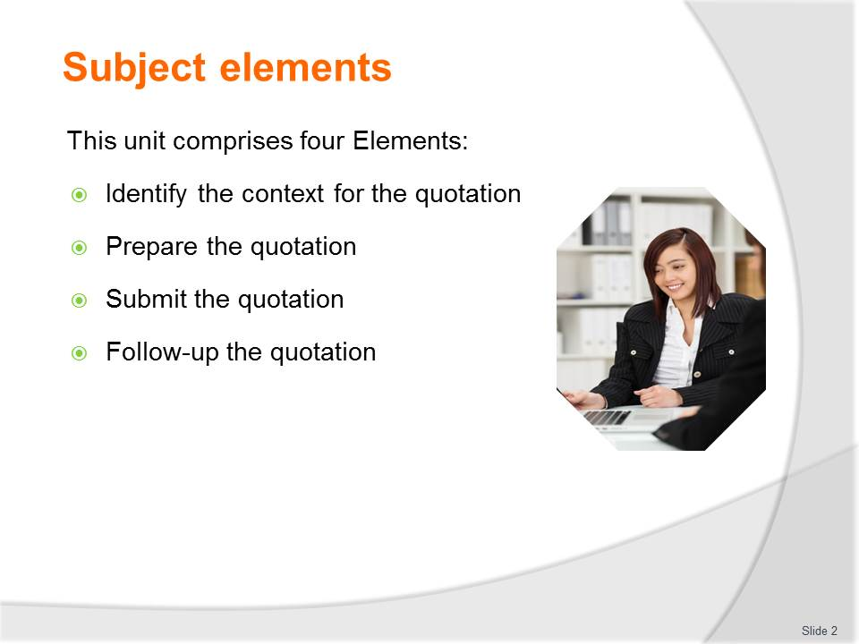
Slide No | Trainer Notes
Trainer advises this Unit comprises four Elements, as listed on the slide explaining:
- Each Element comprises a number of Performance Criteria which will be identified throughout the class and explained in detail
- Trainees can obtain more detail from their Trainee Manual
- At times the course presents advice and information about various protocols but where their workplace requirements differ to what is presented, the workplace practices and standards, as well as policies and procedures must be observed.

Slide
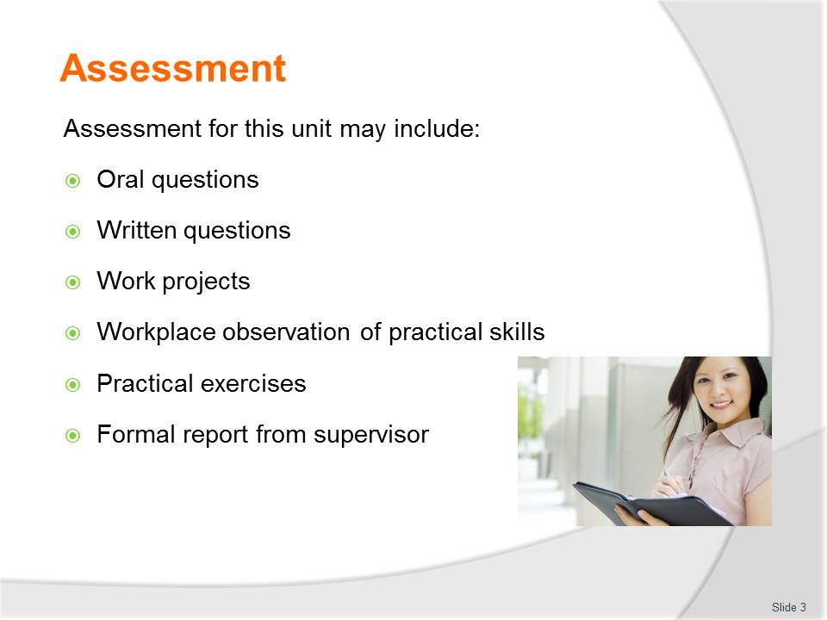
Slide No | Trainer Notes
Trainer advises that assessment for this Unit may take several forms all of which are aimed at verifying they have achieved competency for the Unit as required.
Trainer indicates the methods of assessment that will be applied to them for this Unit.

Slide

Slide No | Trainer Notes
Introduce topic
Class Activity – General Discussion
Ask general questions:
- What is a quotation?
- What is its purpose?

Slide
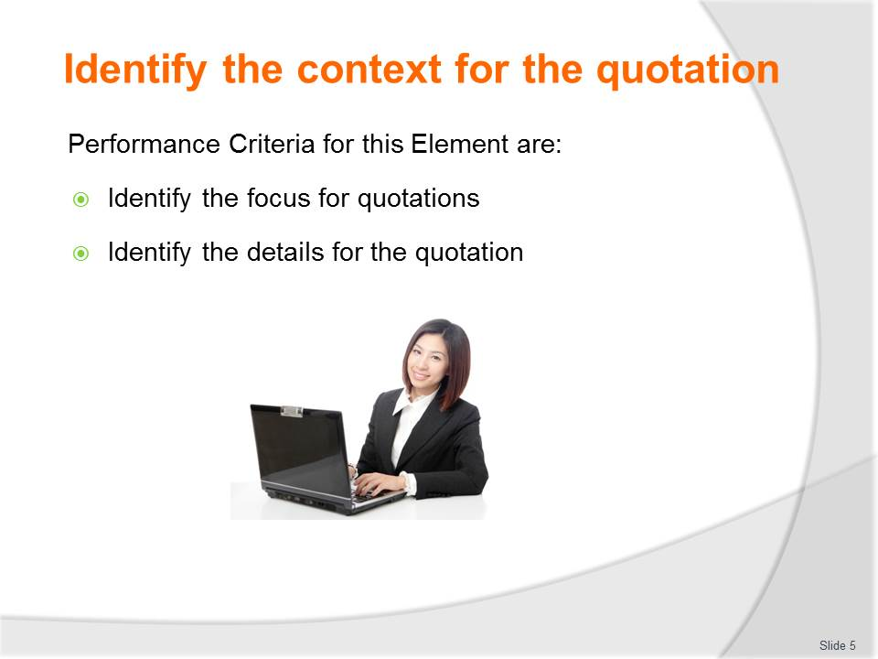
Slide No | Trainer Notes
 | Trainer identifies the Performance Criteria for this Element, as listed on the slide.

Slide
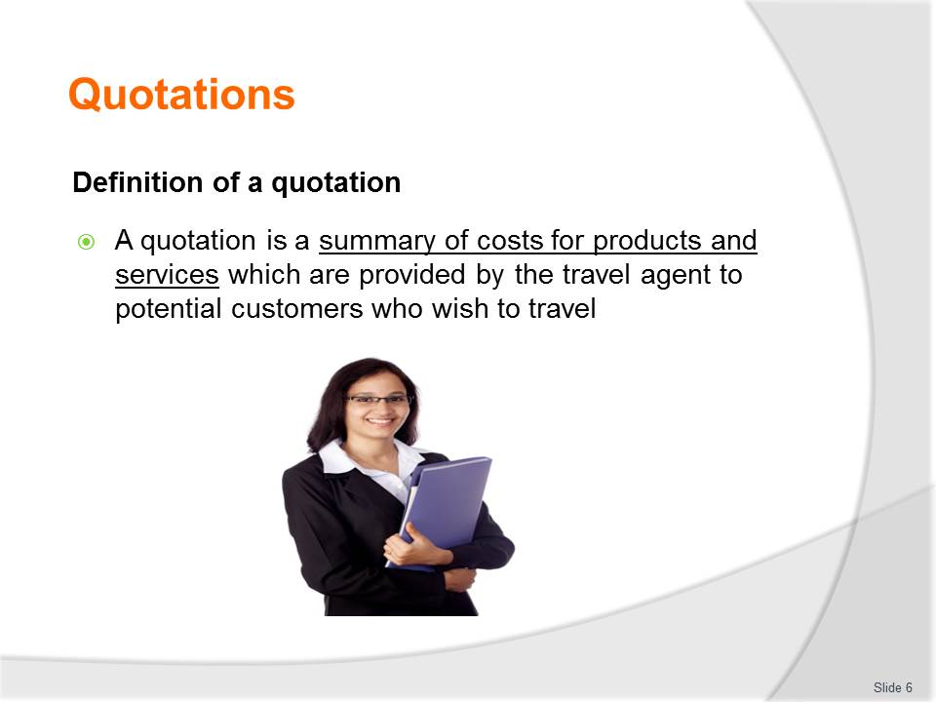
Slide No | Trainer Notes
Class Activity – Discussion and Show
Ask general questions:
- What information is included in a proposal?
- Trainer to show audience copies of an itinerary.

Slide
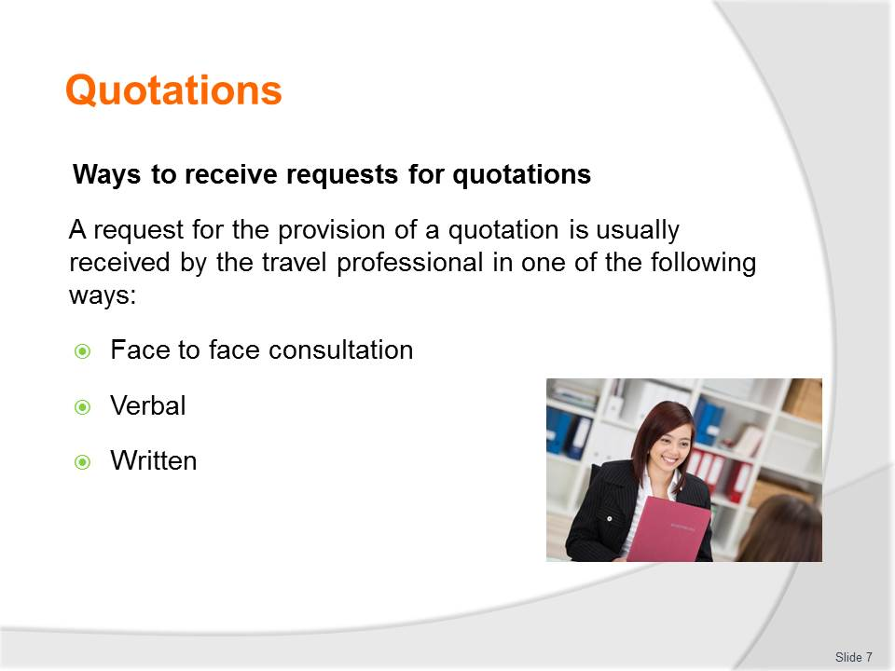
Slide No | Trainer Notes
Class Activity – Questions
- How do most proposals come in?
- Who uses travel agents to prepare travel documentation?

Slide
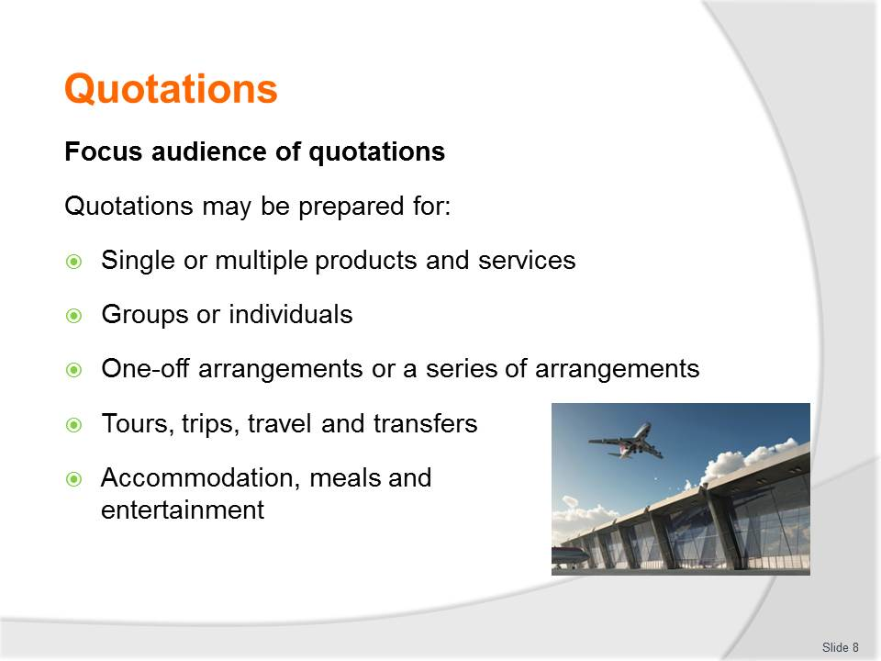
Slide No | Trainer Notes
Class Activity – Questions
- How would quotations vary taking into consideration these points?

Slide
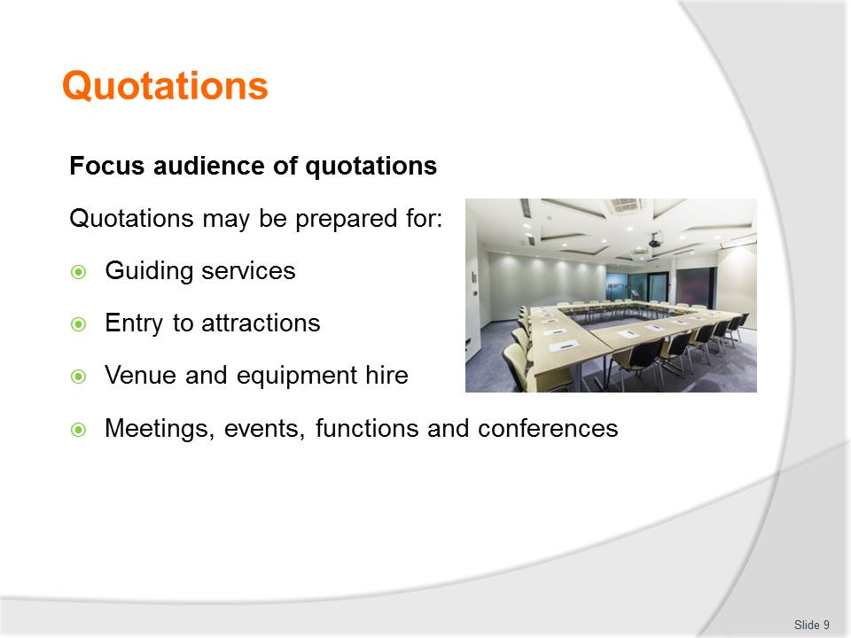
Slide No | Trainer Notes
Class Activity – Questions
- How would quotations vary taking into consideration these points?

Slide
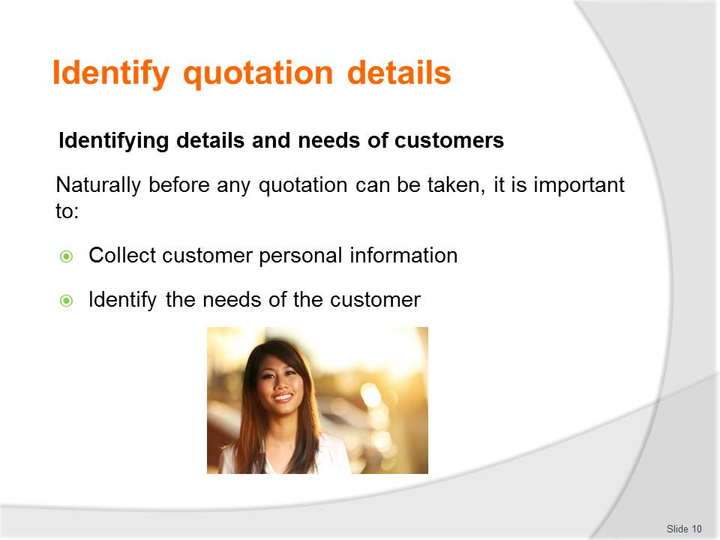
Slide No | Trainer Notes
Class Activity – Questions
- How can you collect their personal information?
- How can you identify travel needs?

Slide
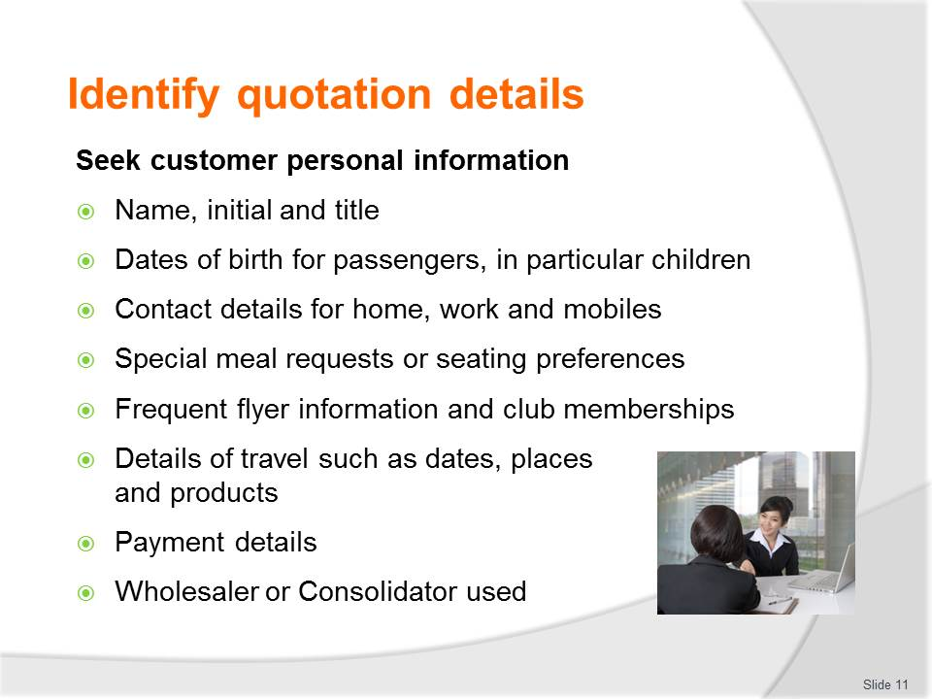
Slide No | Trainer Notes
General Discussion
Discuss information to be collected for each of these points.
Role Play
In pairs, one person is the travel agent and the other person the customer seeking a travel quotation.
The travel quotation will be based on the thoughts of the customer.
The travel agent must gather information and write answers done in an accurate manner.

Slide
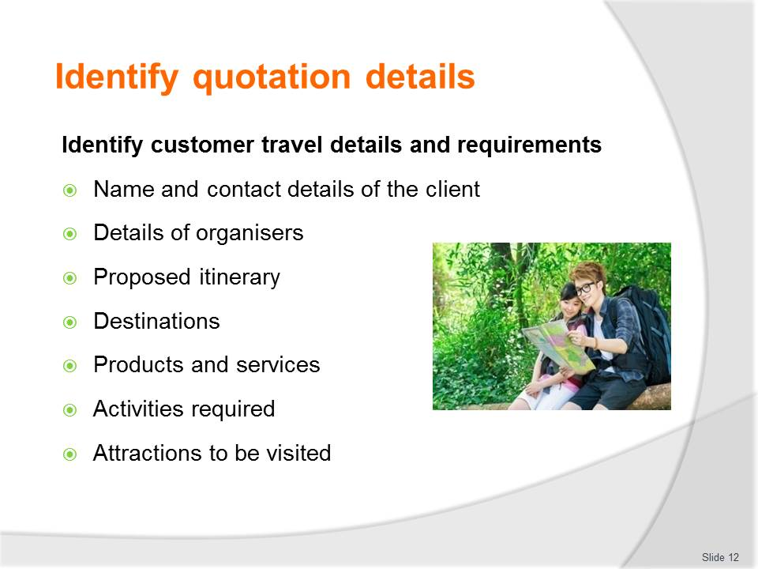
Slide No | Trainer Notes
General Discussion
Discuss information to be collected for each of these points.
Role Play
In pairs, one person is the travel agent and the other person the customer seeking a travel quotation.
The travel quotation will be based on the thoughts of the customer.
The travel agent must gather information and write answers done in an accurate manner.

Slide
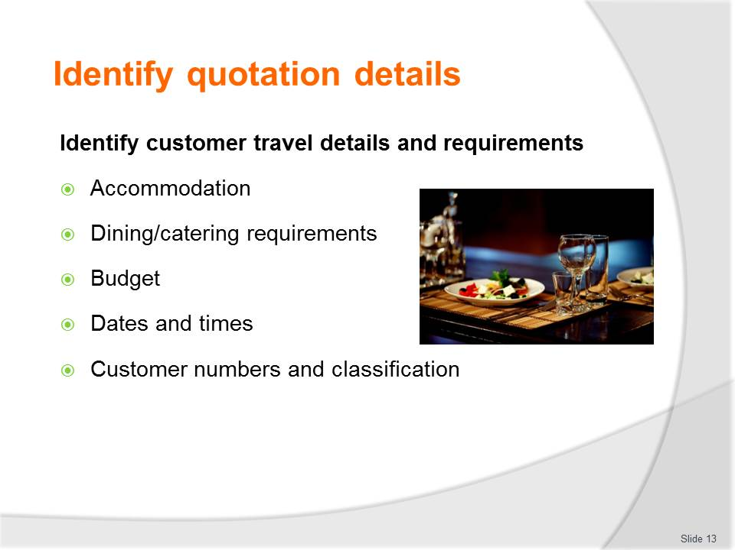
Slide No | Trainer Notes
General Discussion
Discuss information to be collected for each of these points.
Role Play
In pairs, one person is the travel agent and the other person the customer seeking a travel quotation.
The travel quotation will be based on the thoughts of the customer.
The travel agent must gather information and write answers done in an accurate manner.

Slide
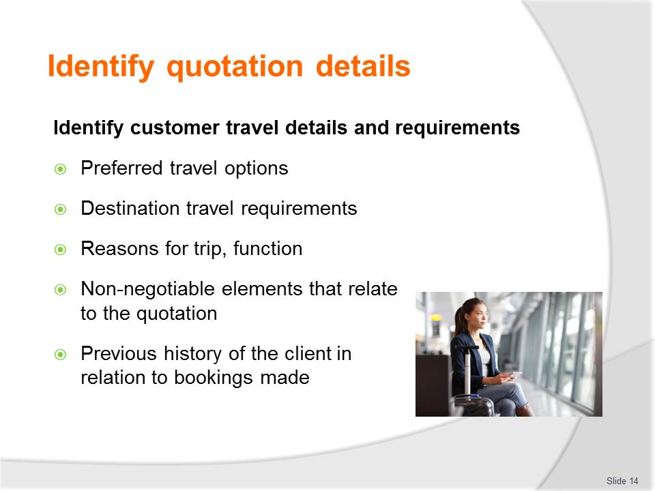
Slide No | Trainer Notes
General Discussion
Discuss information to be collected for each of these points.
Role Play
In pairs, one person is the travel agent and the other person the customer seeking a travel quotation.
The travel quotation will be based on the thoughts of the customer.
The travel agent must gather information and write answers done in an accurate manner.

Slide

Slide No | Trainer Notes
Introduce topic
Class Activity – General Discussion
Ask general questions:
- What information is needed to prepare the quotation?
- What activities are associated with preparing a quotation?

Slide
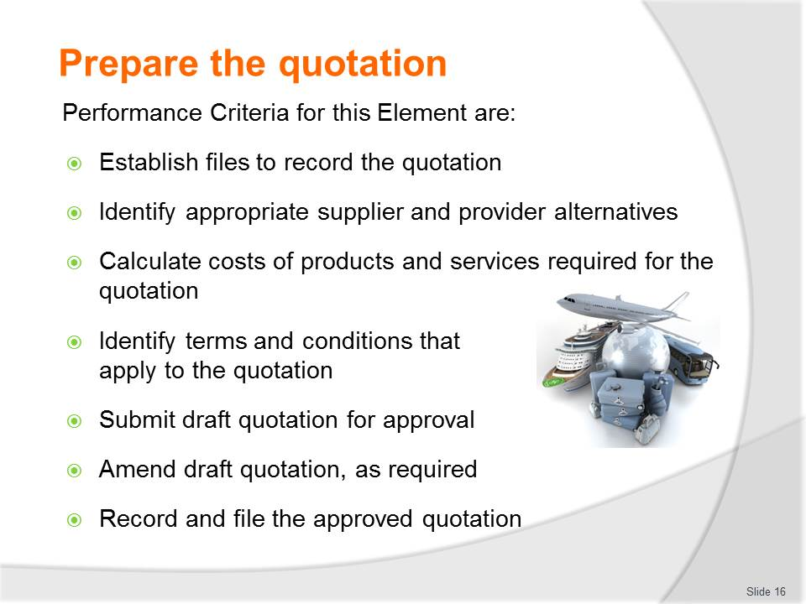
Slide No | Trainer Notes
 | Trainer identifies the Performance Criteria for this Element, as listed on the slide.

Slide
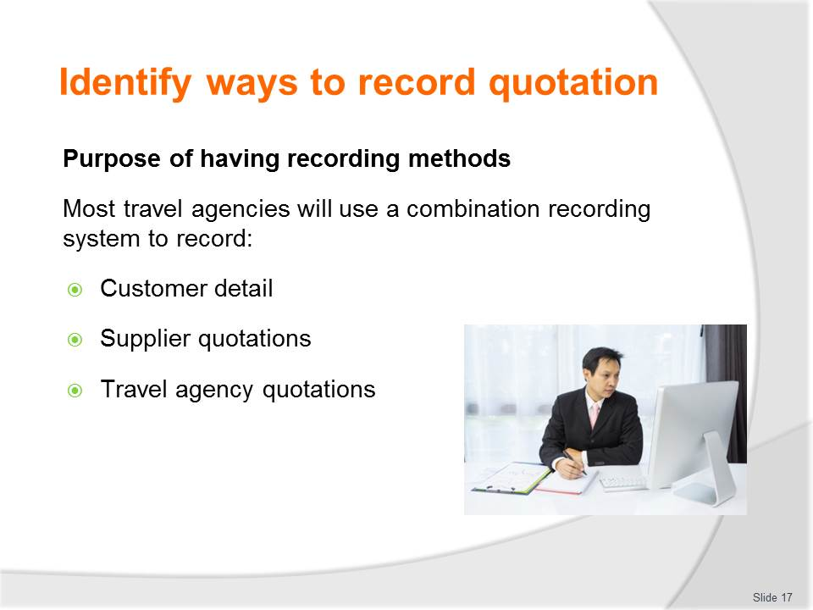
Slide No | Trainer Notes
Class Activity – Questions
- How can information be recorded?

Slide
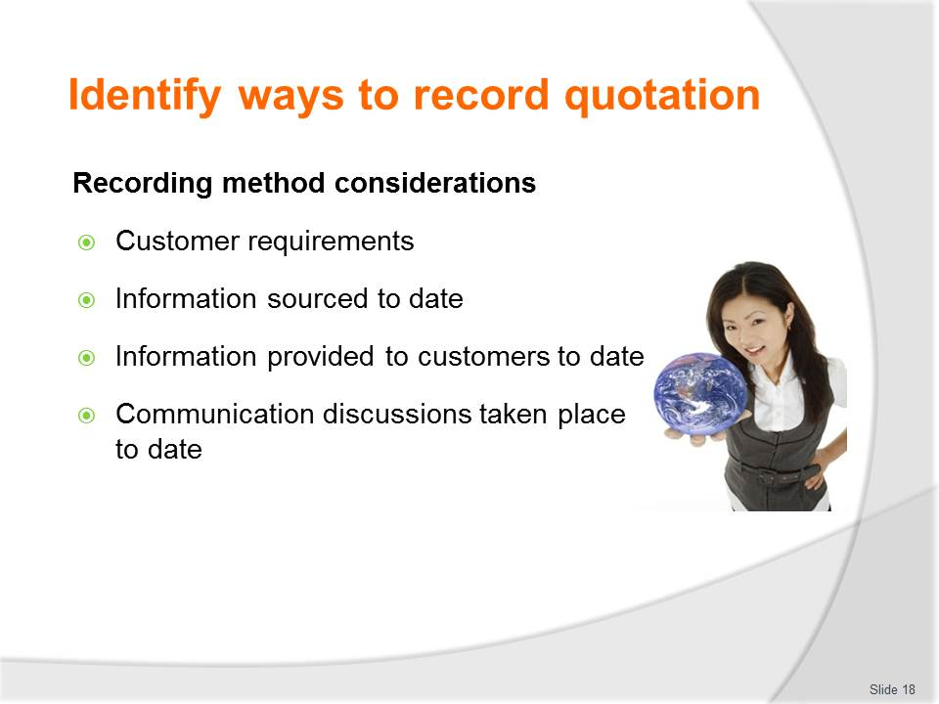
Slide No | Trainer Notes
Class Activity – Discussion and Questions
- Discuss these considerations
- How would they affect the construction of a quotation?

Slide
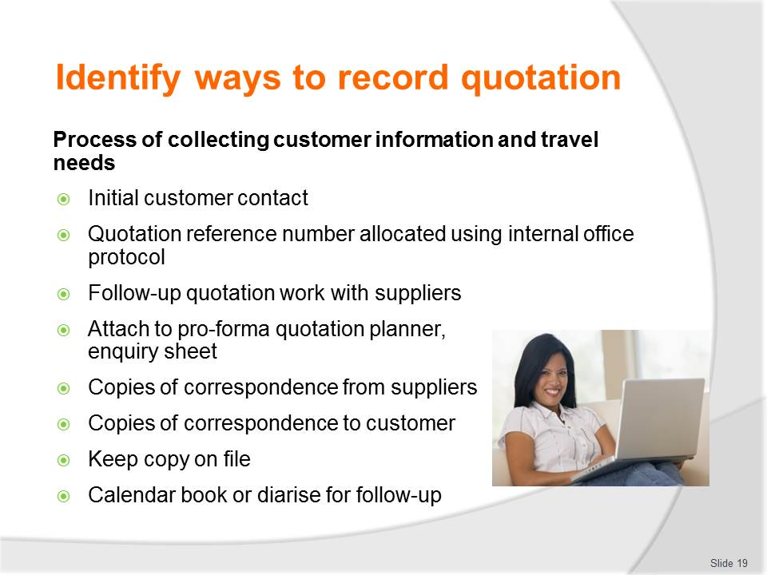
Slide No | Trainer Notes
Class Activity – Discuss process
- Trainer to discuss the process providing demonstrations or examples.

Slide

Slide No | Trainer Notes
Class Activity – Questions
- Why is it important to record information accurately?

Slide
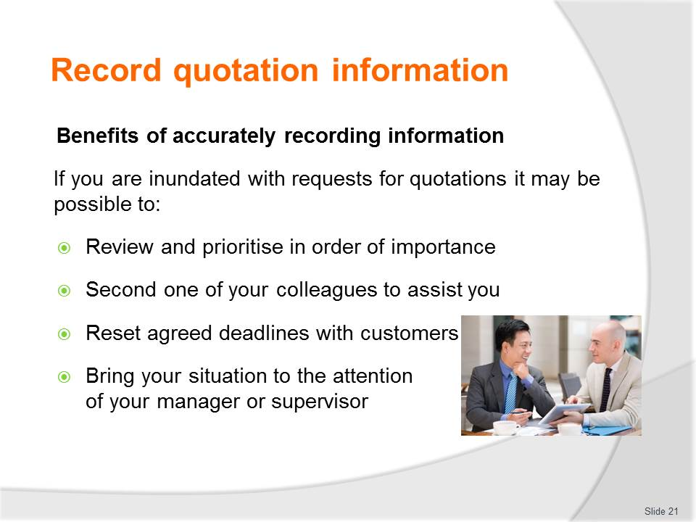
Slide No | Trainer Notes
Class Activity – Questions
- What are the benefits of record information accurately?

Slide

Slide No | Trainer Notes
Class Activity – Explanation of codes and quiz
- Trainer to show audience a range of industry codes for each of the points in the slide
- Trainer to prepare a quiz based on industry codes.

Slide
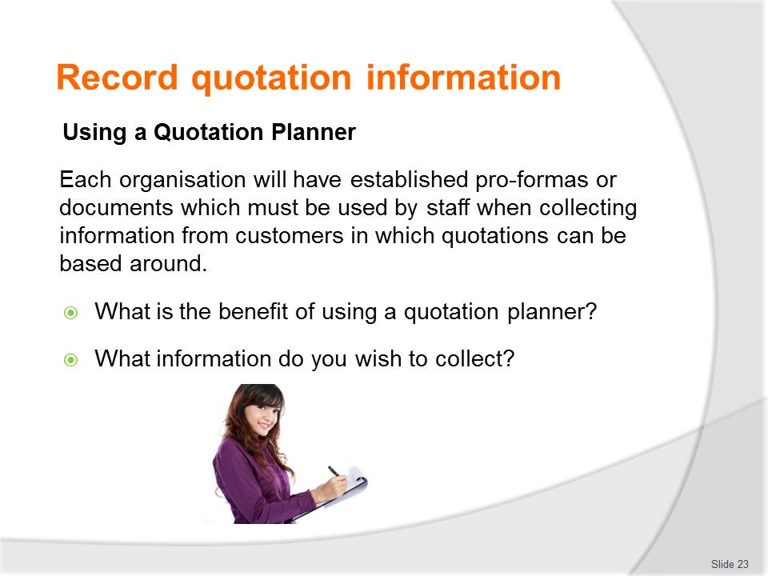
Slide No | Trainer Notes
Class Activity – Demonstration and activity
- Trainer to show audience copies of a planner
- Audience to create their own planners or think of questions they would include in their own planners.

Slide
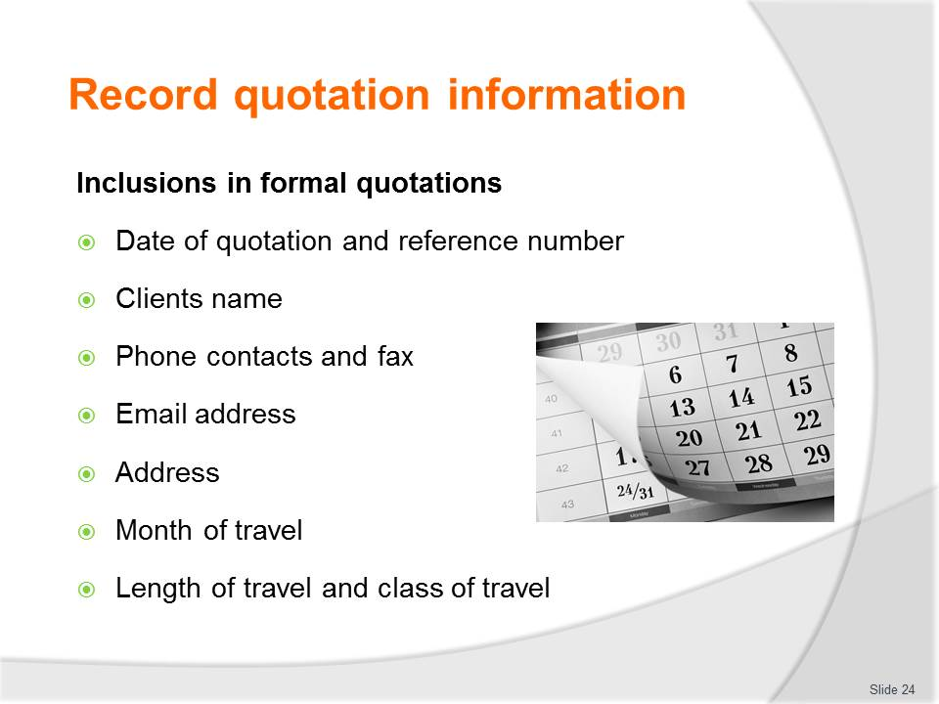
Slide No | Trainer Notes
Class Activity – Discussion
- Discuss the importance of these points in a quotation
- Provide examples or specific pieces of information that must be included for each point.

Slide
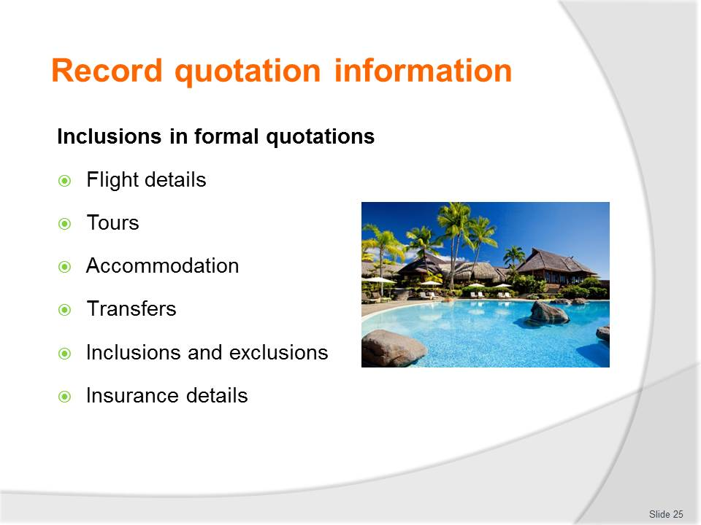
Slide No | Trainer Notes
Class Activity – Discussion
- Discuss the importance of these points in a quotation
- Provide examples or specific pieces of information that must be included for each point.

Slide
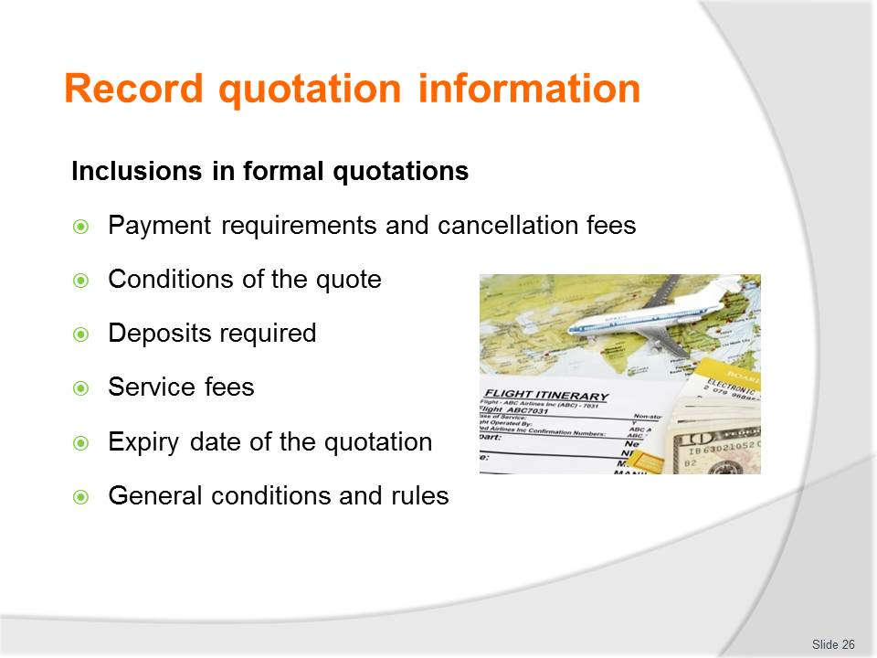
Slide No | Trainer Notes
Class Activity – Discussion
- Discuss the importance of these points in a quotation
- Provide examples or specific pieces of information that must be included for each point.

Slide
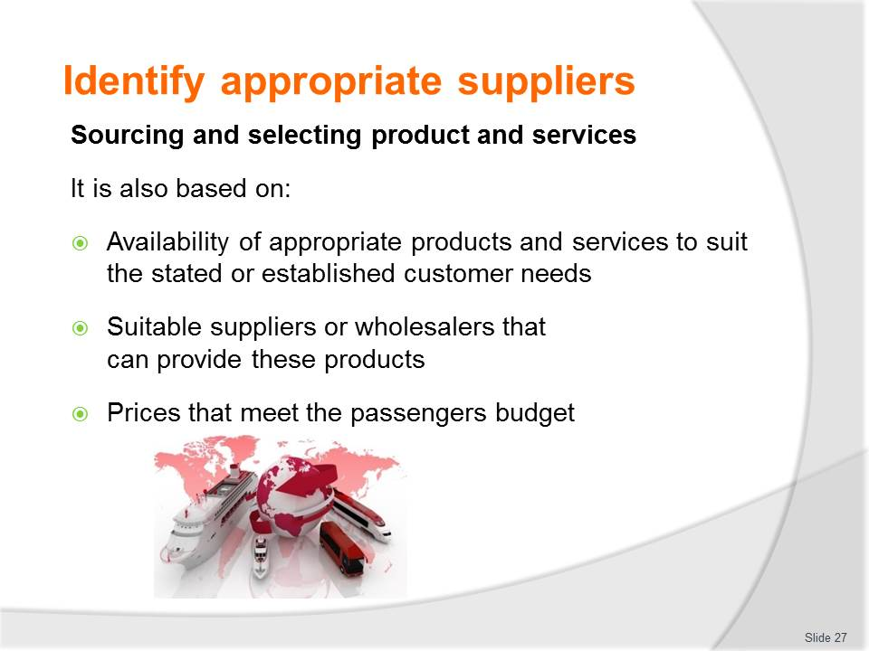
Slide No | Trainer Notes
Class Activity – Identify products and services
- Audience to prepare a list of possible products and services.

Slide
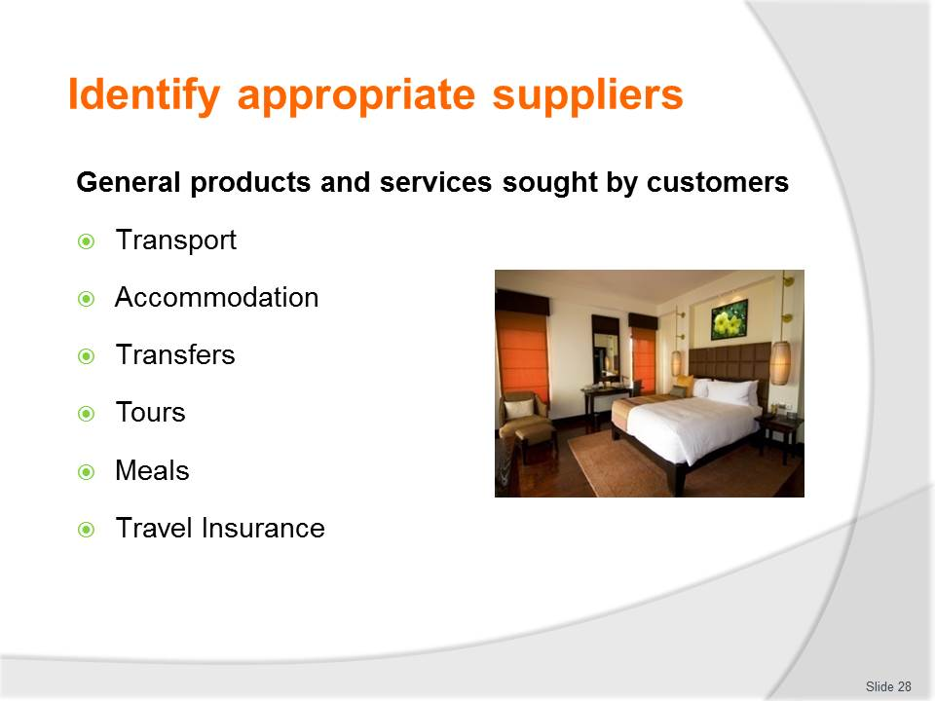
Slide No | Trainer Notes
Class Activity – Identify products and services
- Audience to prepare a list of possible products and services.

Slide
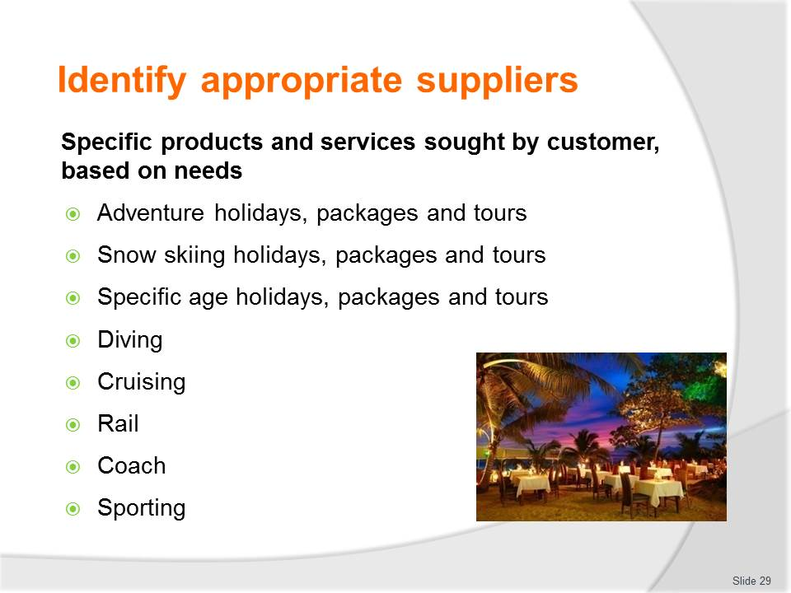
Slide No | Trainer Notes
Class Activity – Identify products and services
- Audience to prepare a list of possible products and services.

Slide
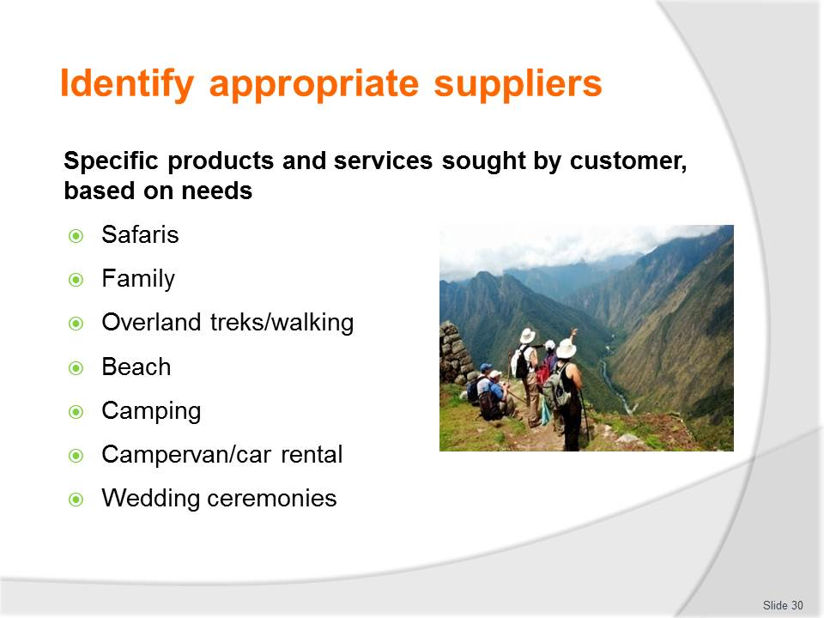
Slide No | Trainer Notes
Class Activity – Identify products and services
- Audience to prepare a list of possible products and services.

Slide
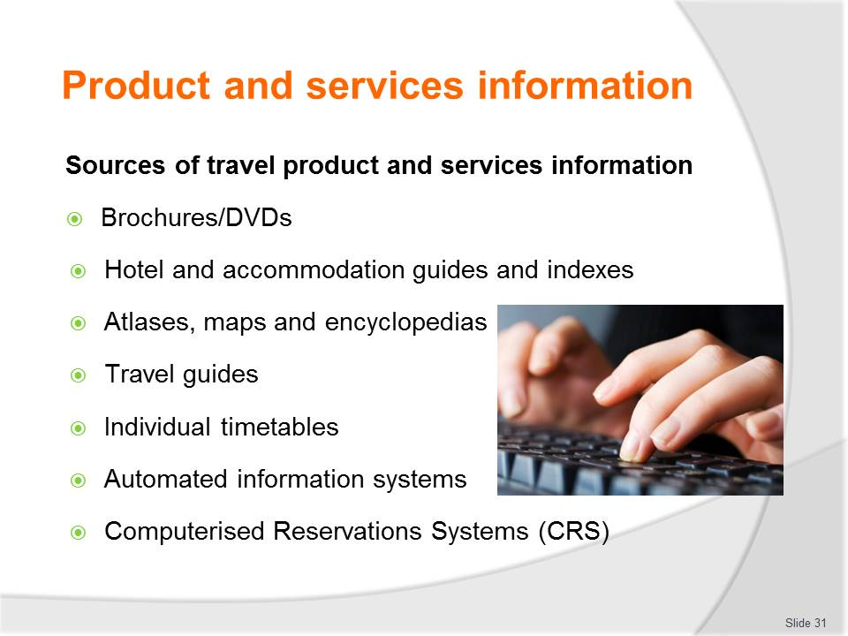
Slide No | Trainer Notes
Class Activity – Identify sources of information
- Trainer to show sources of information
- What information can be gathered from each source?

Slide

Slide No | Trainer Notes
Class Activity – Identify sources of information
- Trainer to show sources of information
- What information can be gathered from each source?

Slide
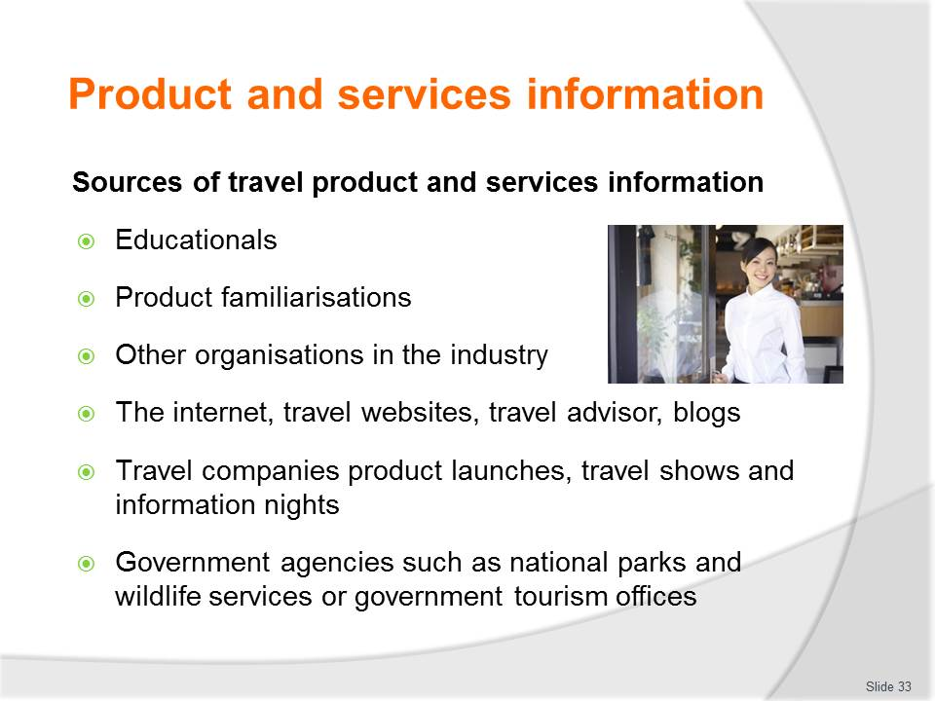
Slide No | Trainer Notes
Class Activity – Identify sources of information
- Trainer to show sources of information
- What information can be gathered from each source?

Slide
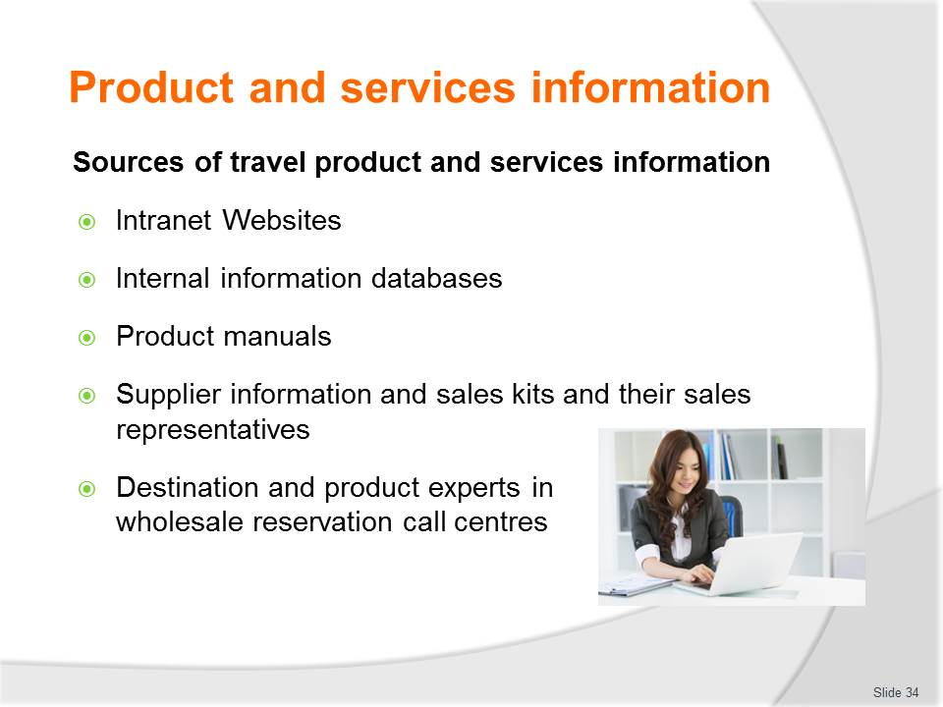
Slide No | Trainer Notes
Class Activity – Identify sources of information
- Trainer to show sources of information
- What information can be gathered from each source?

Slide

Slide No | Trainer Notes
Class Activity – Identify sources of information
- Trainer to show sources of information
- What information can be gathered from each source?

Slide
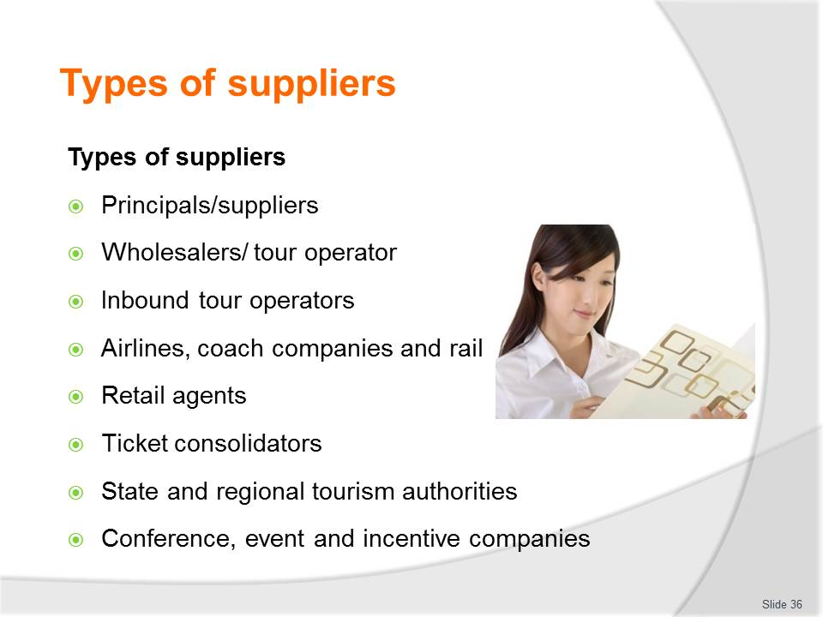
Slide No | Trainer Notes
Class Activity – Identify suppliers and Research activity
- Trainer to discuss the different types of companies under each point
- Audience to research companies under each of these points and identify the services they provide to travel agents and customers.

Slide
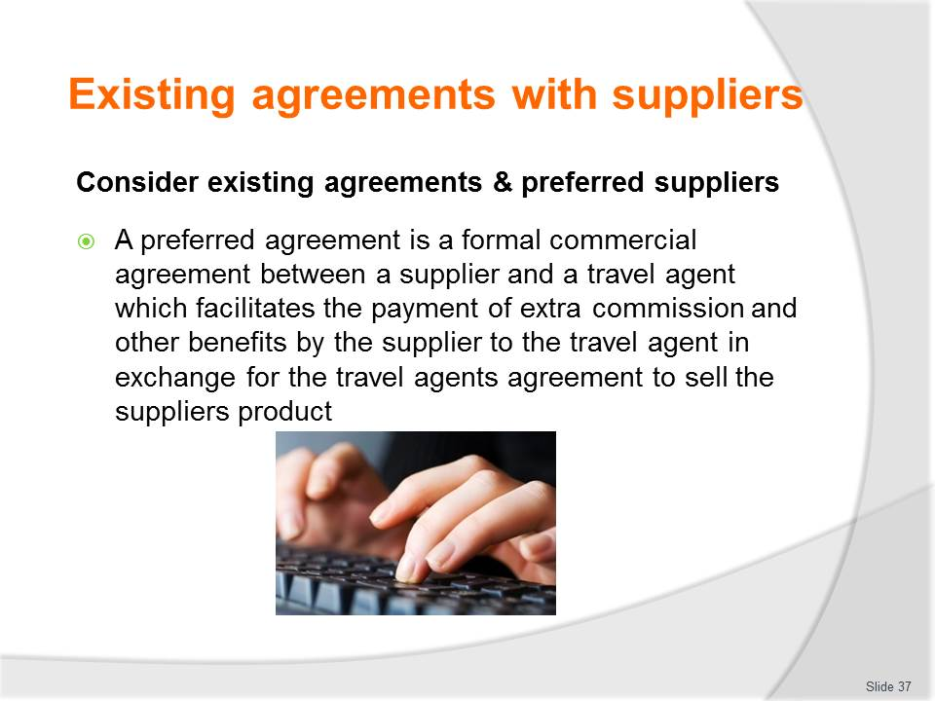
Slide No | Trainer Notes
Class Activity – Identify preferred supplier agreement
- Trainer to show example of a preferred supplier agreement
- What needs to be considered when developing a preferred supplier agreement?

Slide
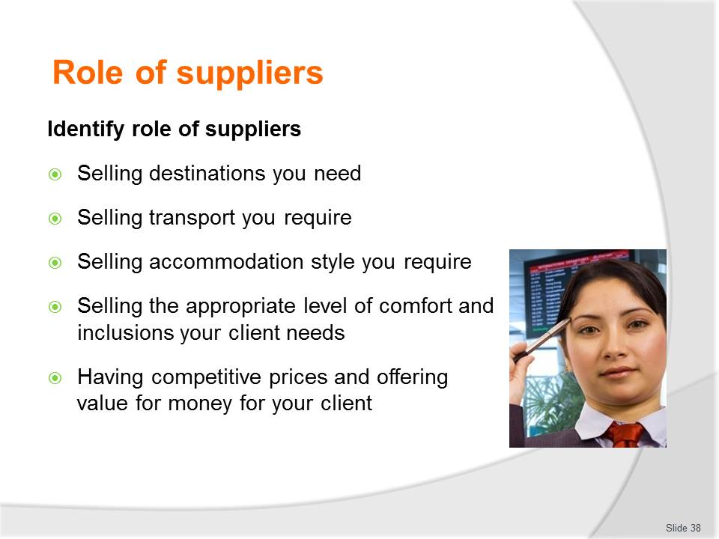
Slide No | Trainer Notes
Class Activity – Discuss role of suppliers
- What activities are performed under each of these points?
- How can you improve these individual roles?

Slide
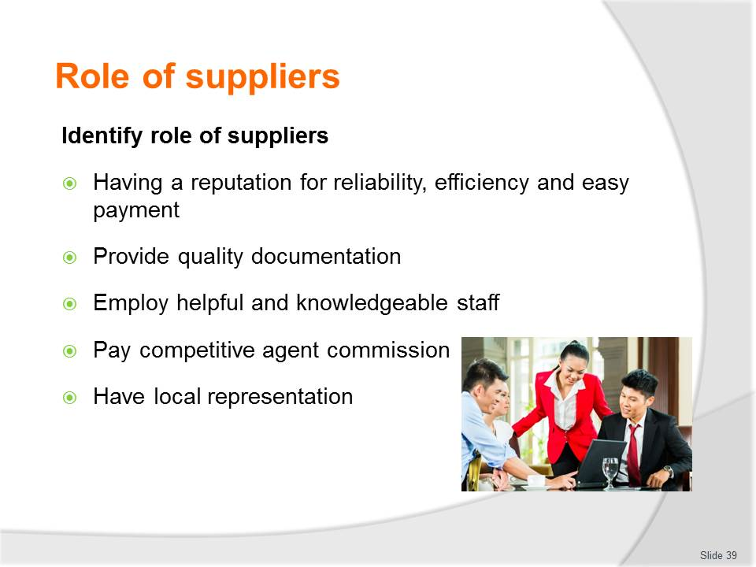
Slide No | Trainer Notes
Class Activity – Discuss role of suppliers
- What activities are performed under each of these points?
- How can you improve these individual roles?

Slide
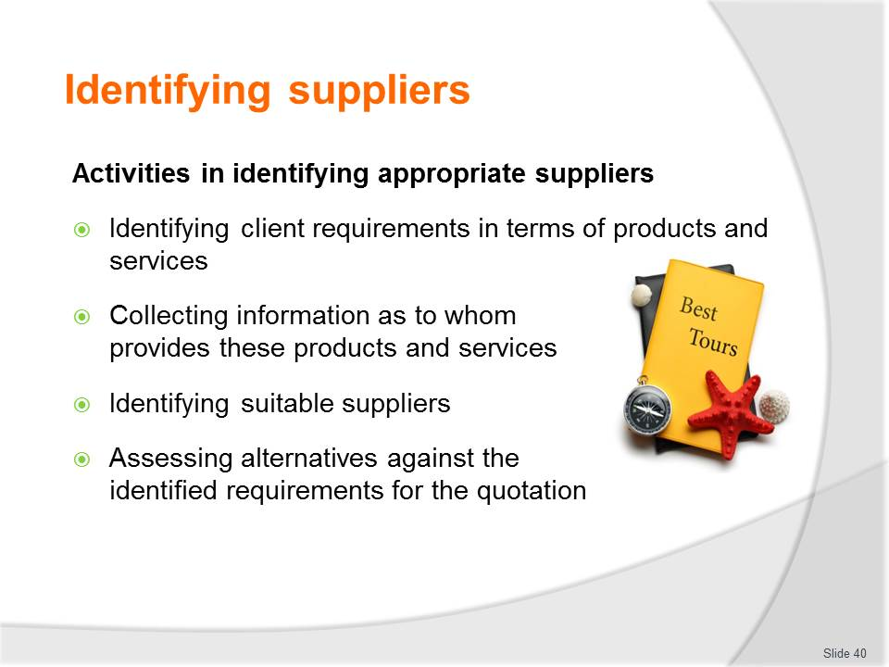
Slide No | Trainer Notes
Class Activity – Discuss role of identifying suppliers
- Discuss these activities
- Trainer to provide personal experiences in selecting suppliers.

Slide
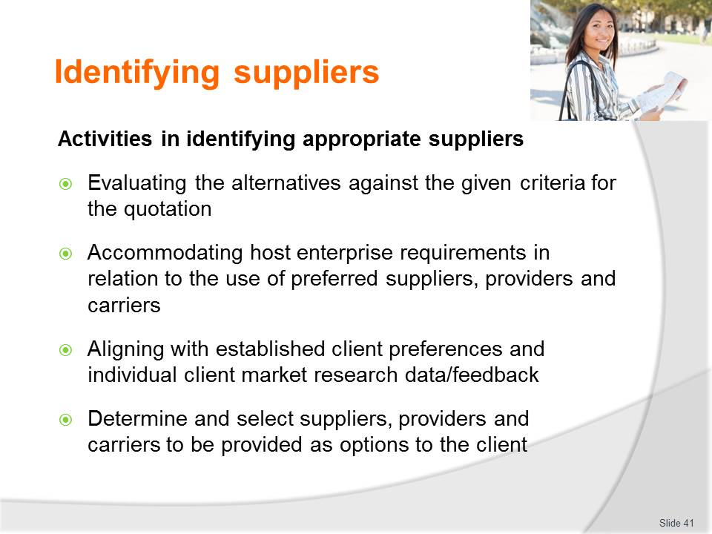
Slide No | Trainer Notes
Class Activity – Discuss role of identifying suppliers
- Discuss these activities
- Trainer to provide personal experiences in selecting suppliers.

Slide
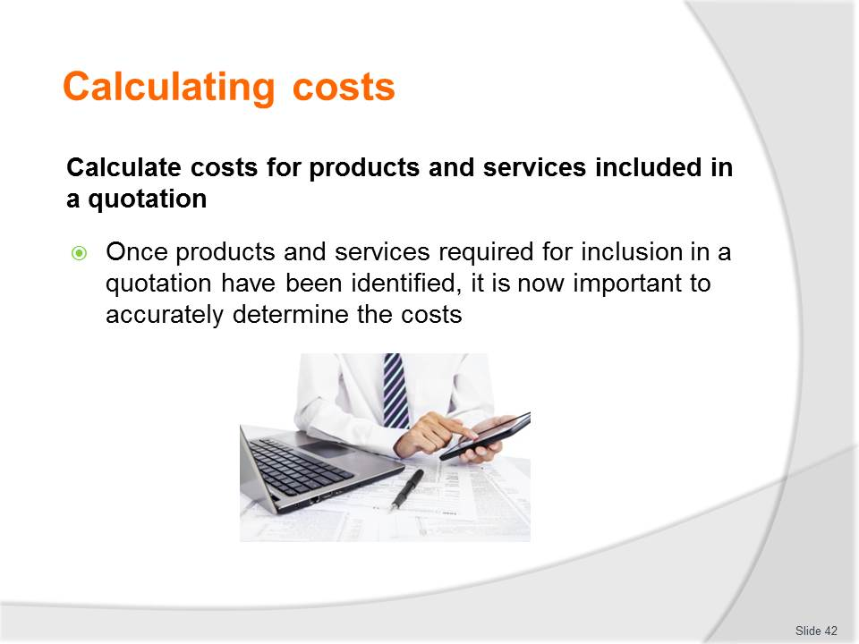
Slide No | Trainer Notes
Class Activity – Discuss costs
- What costs must be taken into account when developing proposals?

Slide
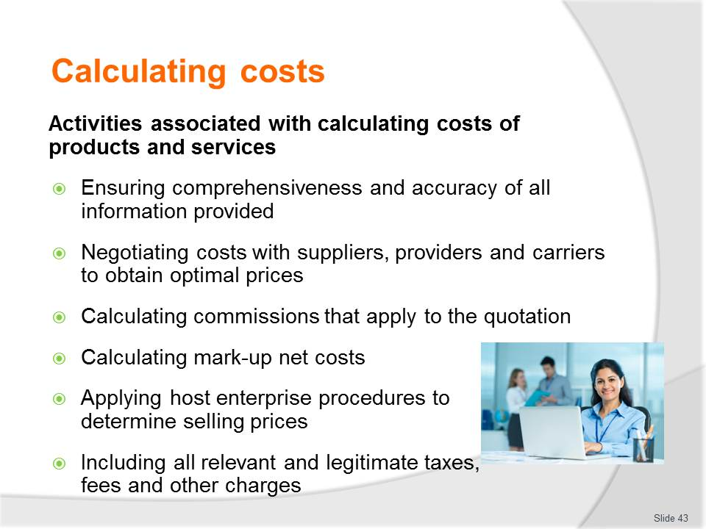
Slide No | Trainer Notes
Class Activity – Discuss how to calculate costs
- Discuss these activities
- Trainer to provide personal experiences in calculating costs.

Slide
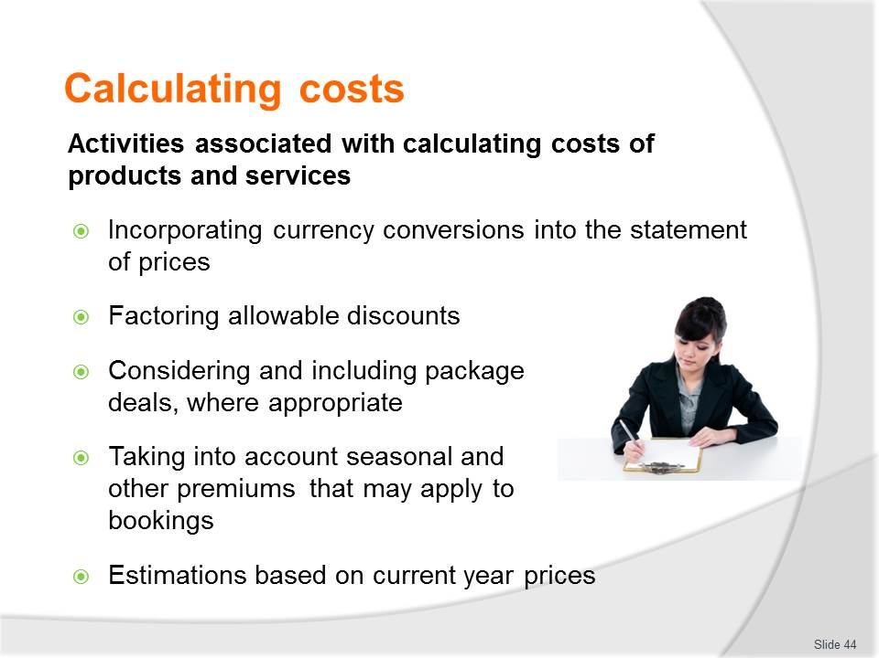
Slide No | Trainer Notes
Class Activity – Discuss how to calculate costs
- Discuss these activities
- Trainer to provide personal experiences in calculating costs.

Slide
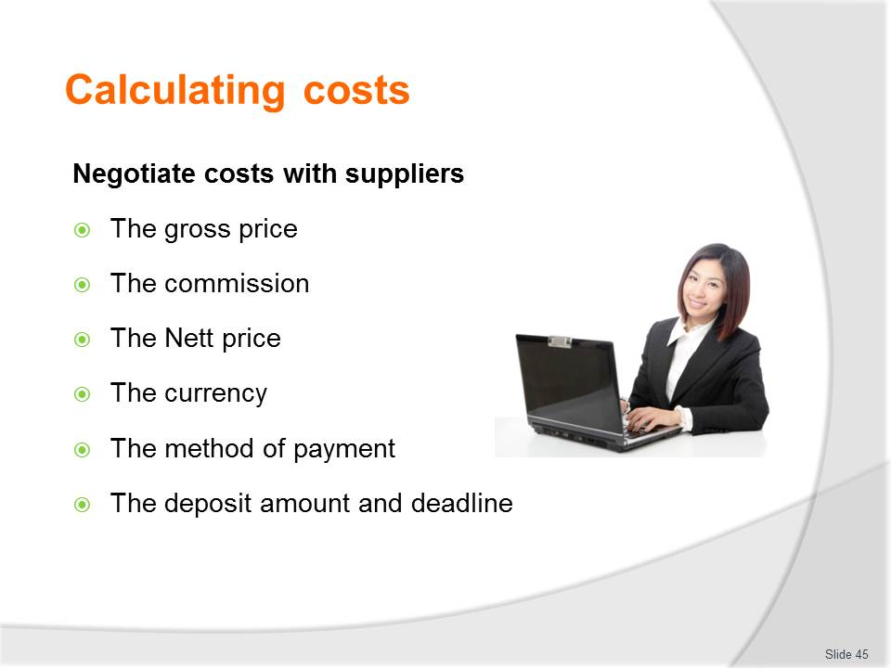
Slide No | Trainer Notes
Class Activity – Discuss how to negotiate costs with suppliers
- Discuss these activities
- Trainer to provide personal experiences in negotiating costs with suppliers.

Slide
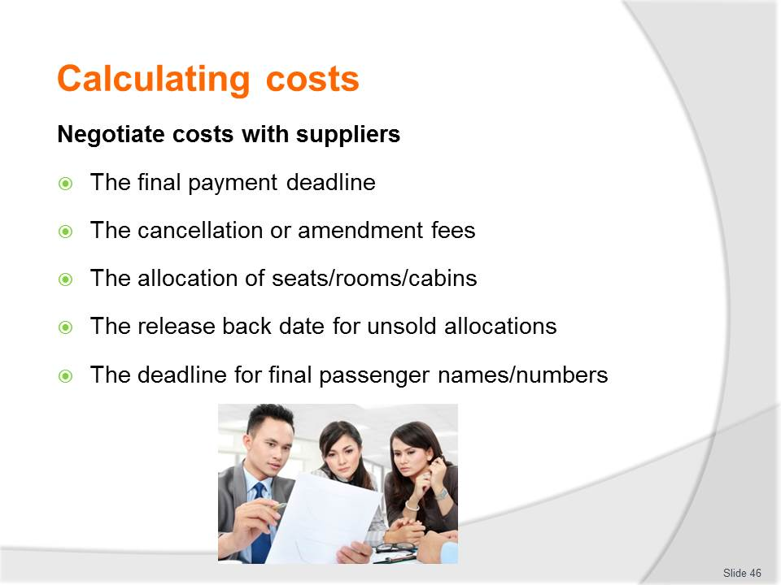
Slide No | Trainer Notes
Class Activity – Discuss how to negotiate costs with suppliers
- Discuss these activities
- Trainer to provide personal experiences in negotiating costs with suppliers.

Slide

Slide No | Trainer Notes
Class Activity – Discuss how to calculate mark ups and commissions
- Trainer to explain how to mark up costs
- Trainer to show and demonstrate costing software or tools
- Trainer to discuss the procedures associated with arranging and collecting commissions.

Slide
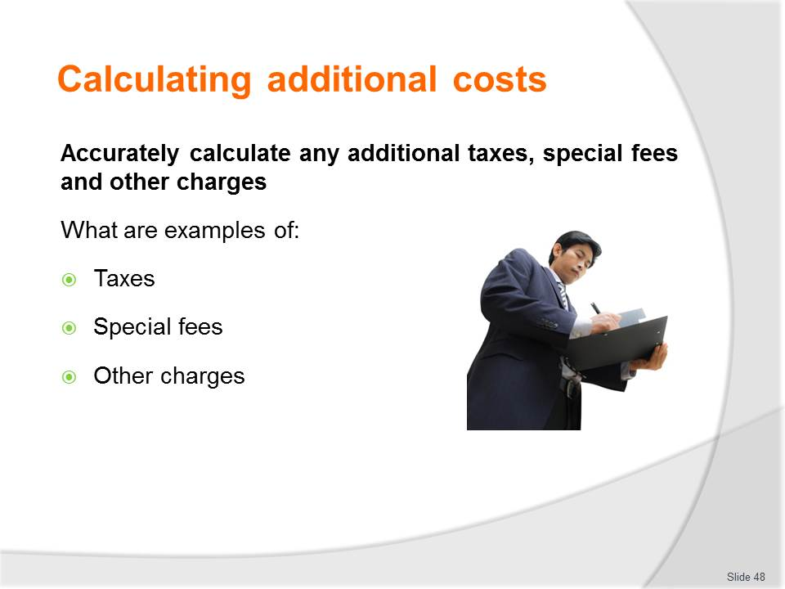
Slide No | Trainer Notes
Class Activity – Discuss questions
- Discuss questions in the slide.

Slide

Slide No | Trainer Notes
Class Activity – Discuss questions
- Discuss questions in the slide.

Slide
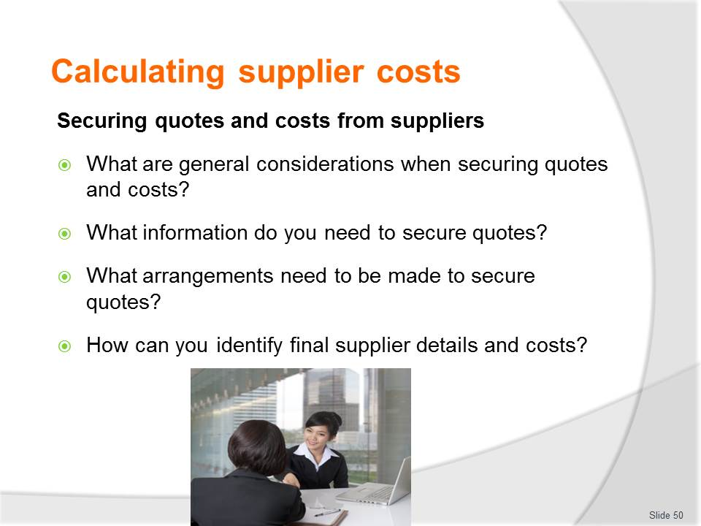
Slide No | Trainer Notes
Class Activity – Discuss questions
- Discuss questions in the slide.

Slide
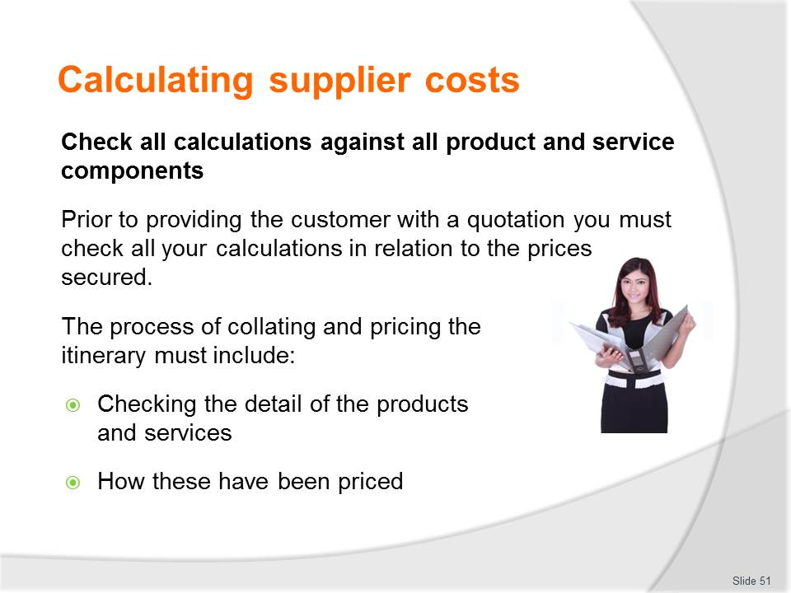
Slide No | Trainer Notes
Class Activity – Discuss how to accurately calculate and check all product and service cost components
- Trainer to explain how to check costs
- Trainer to show and demonstrate costing software or tools.

Slide
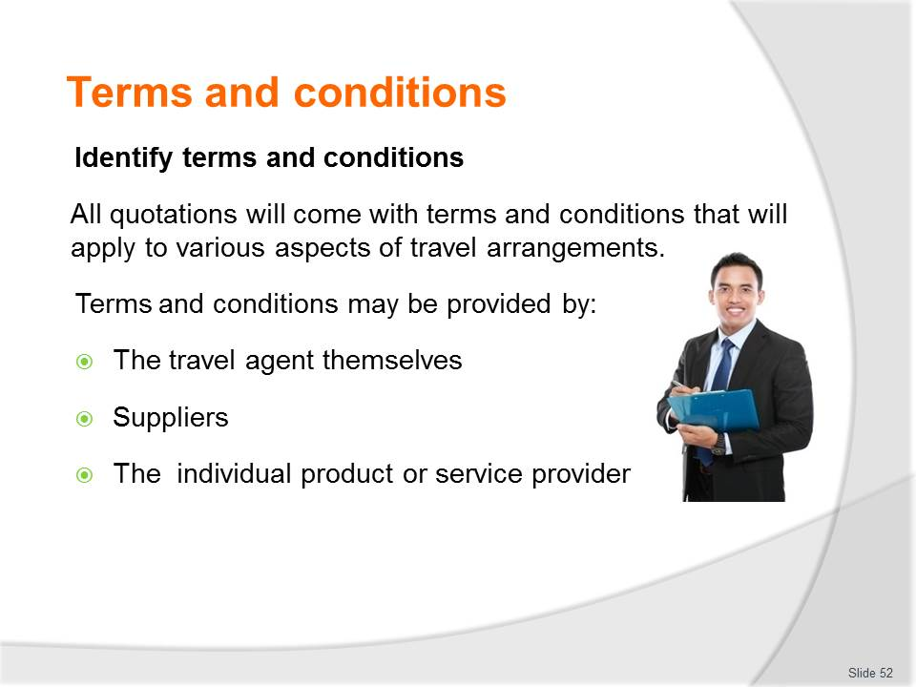
Slide No | Trainer Notes
Class Activity – List terms and conditions
- Audience to prepare list of all possible terms and conditions affecting travel bookings and arrangements.

Slide
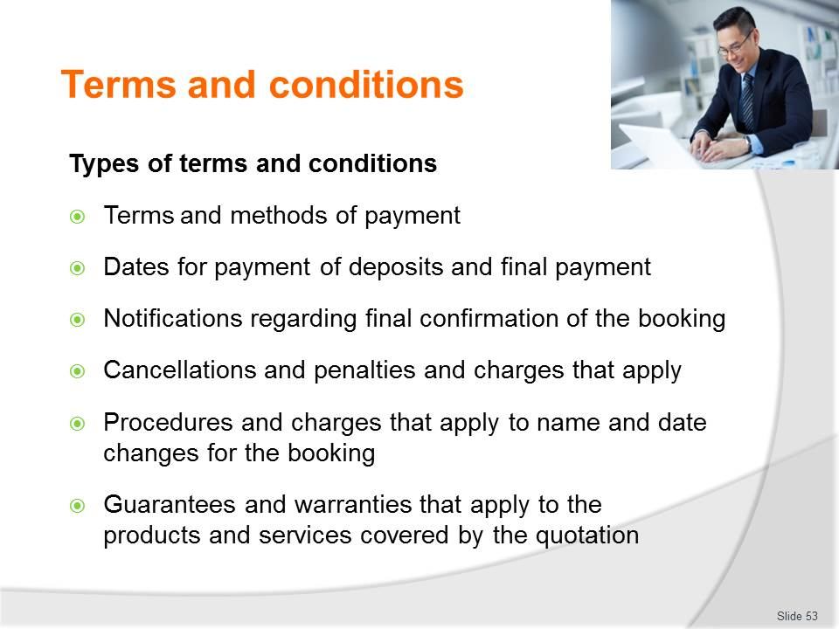
Slide No | Trainer Notes
Class Activity – Discuss terms and conditions
- What is the purpose of each of these terms and conditions?
- What are examples / stipulations of each of these terms and conditions?

Slide
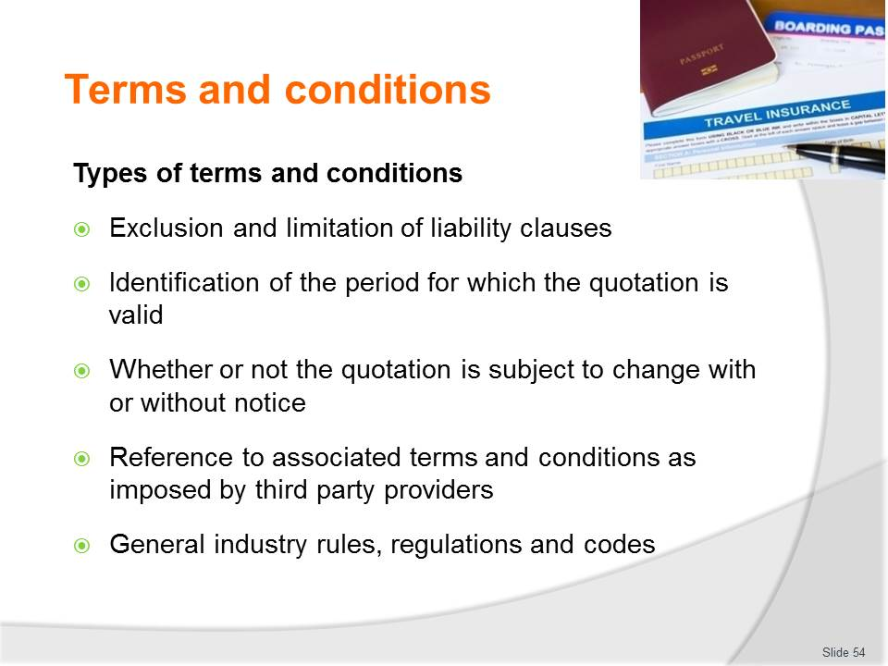
Slide No | Trainer Notes
Class Activity – Discuss terms and conditions
- What is the purpose of each of these terms and conditions?
- What are examples / stipulations of each of these terms and conditions?

Slide
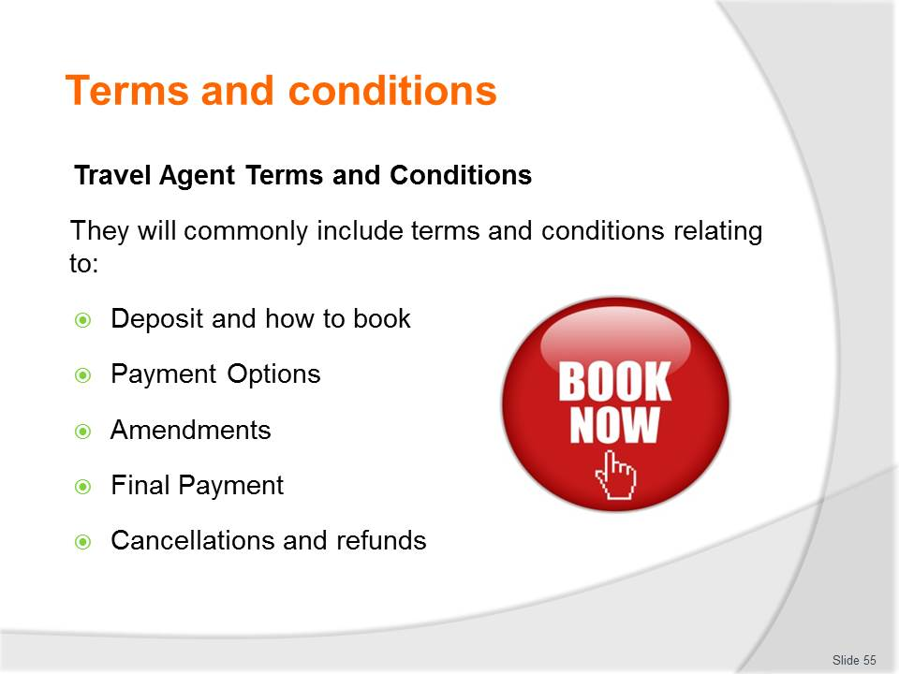
Slide No | Trainer Notes
Class Activity – Discuss terms and conditions
- What is the purpose of each of these terms and conditions?
- What are examples / stipulations of each of these terms and conditions?

Slide
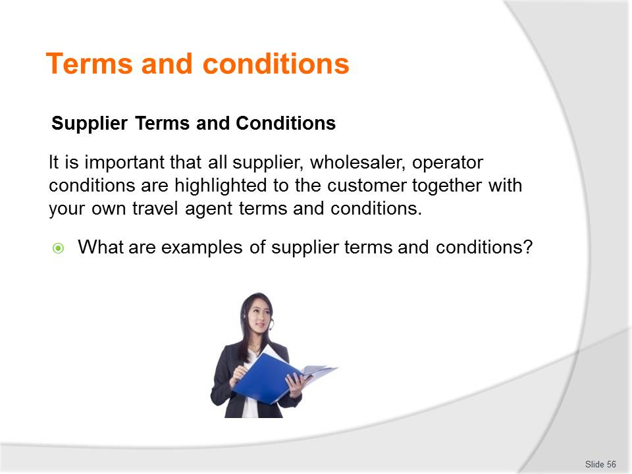
Slide No | Trainer Notes
Class Activity – Discuss questions
- Discuss questions in the slide.

Slide
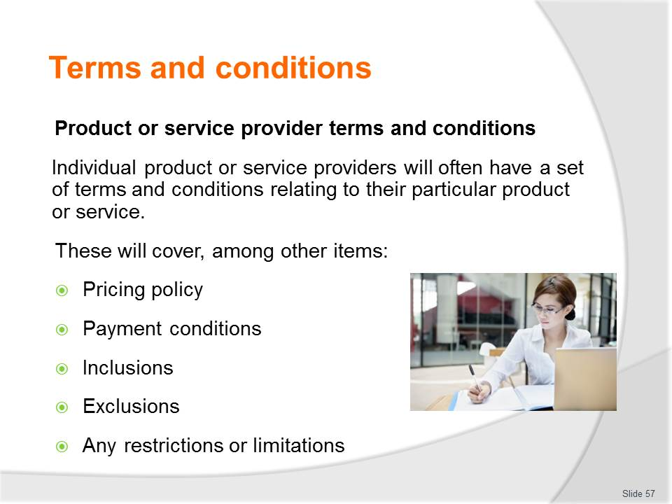
Slide No | Trainer Notes
Class Activity – Discuss terms and conditions
- What is the purpose of each of these terms and conditions?
- What are examples / stipulations of each of these terms and conditions?

Slide

Slide No | Trainer Notes
Class Activity – Prepare draft quotation (relevant for Slides 58 – 62)
- Based on the Work Project Case Study or scenarios created by the Trainer, the Audience is to develop draft quotations for various travel scenarios.

Slide
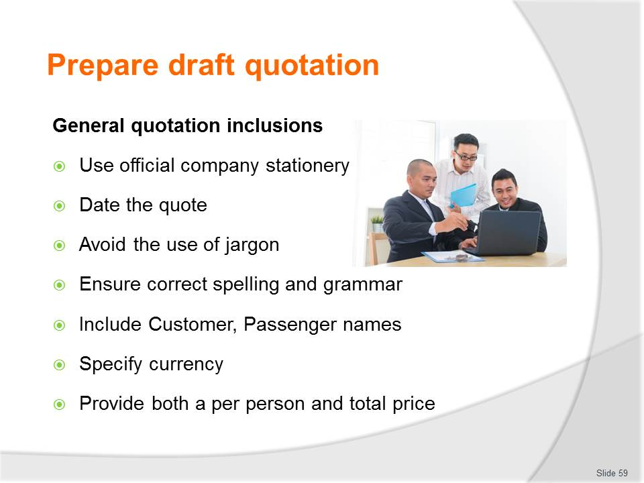
Slide No | Trainer Notes
Class Activity – Prepare draft quotation
- Based on the Work Project Case Study or scenarios created by the Trainer, the Audience is to develop draft quotations for various travel scenarios.

Slide
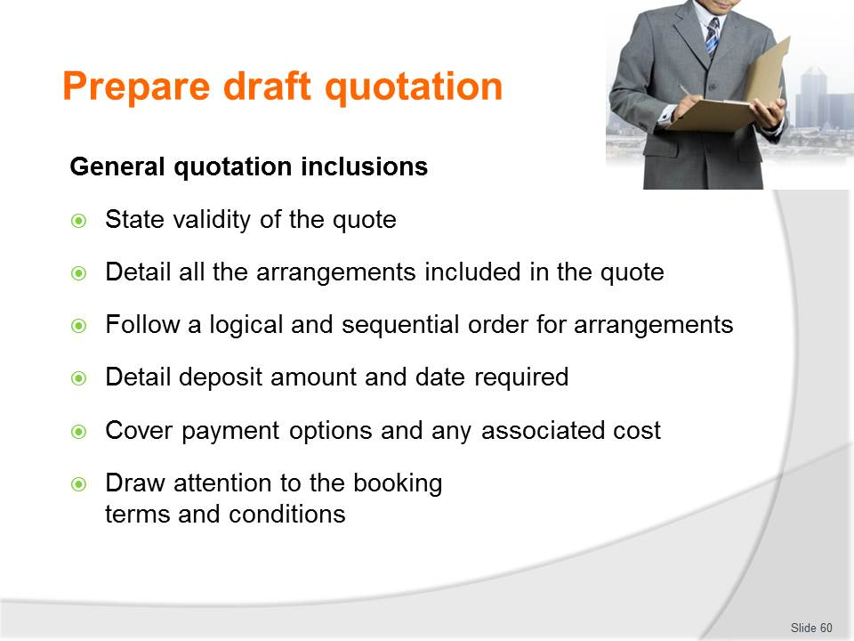
Slide No | Trainer Notes
Class Activity – Prepare draft quotation
- Based on the Work Project Case Study or scenarios created by the Trainer, the Audience is to develop draft quotations for various travel scenarios.

Slide

Slide No | Trainer Notes
Class Activity – Prepare draft quotation
- Based on the Work Project Case Study or scenarios created by the Trainer, the Audience is to develop draft quotations for various travel scenarios.

Slide
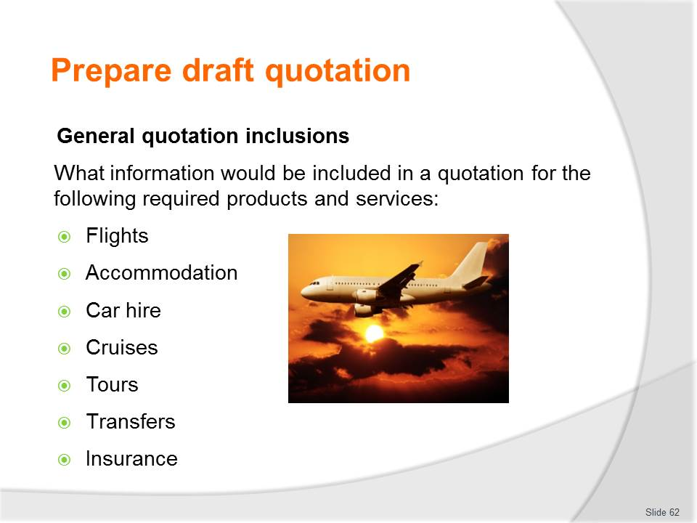
Slide No | Trainer Notes
Class Activity – Prepare draft quotation
- Based on the Work Project Case Study or scenarios created by the Trainer, the Audience is to develop draft quotations for various travel scenarios.

Slide
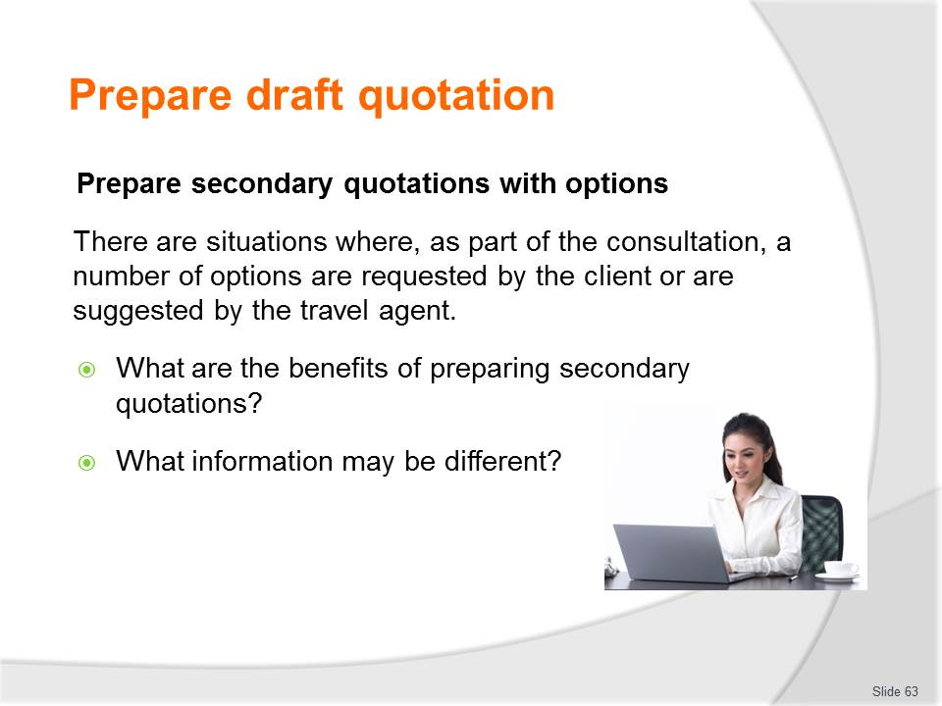
Slide No | Trainer Notes
Class Activity – Discuss questions
- Discuss questions in the slide.

Slide
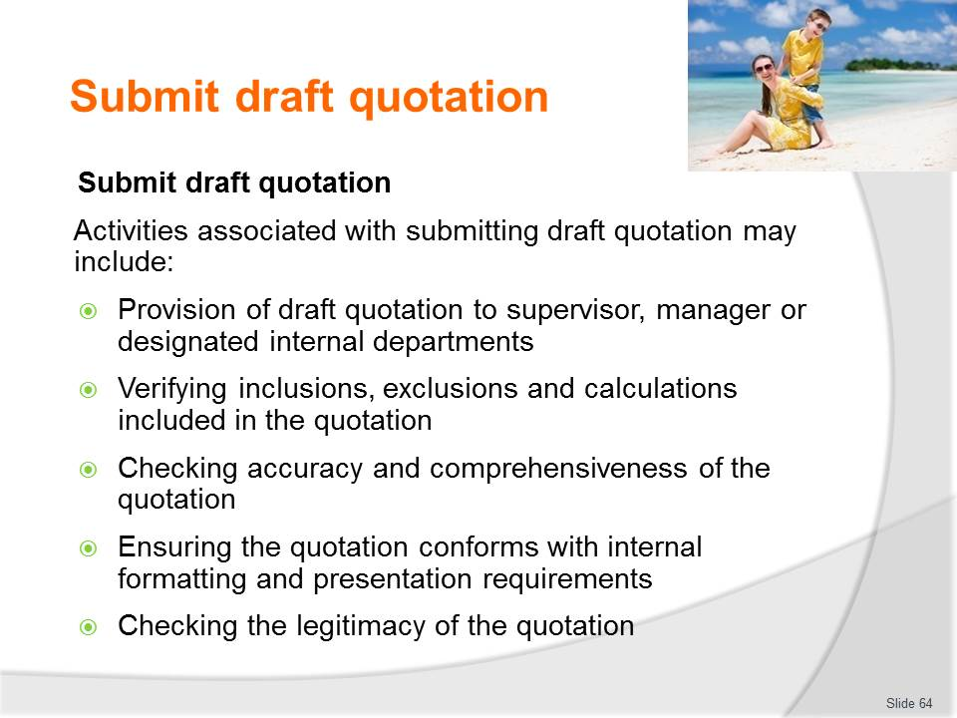
Slide No | Trainer Notes
Class Activity – Discuss submission points
- What are key factors for each point?

Slide

Slide No | Trainer Notes
Class Activity – Discuss submission points
- What are key factors for each point?
- How should the file be recorded and filed?
- How can you identify the ‘latest’ version of a quotation?

Slide
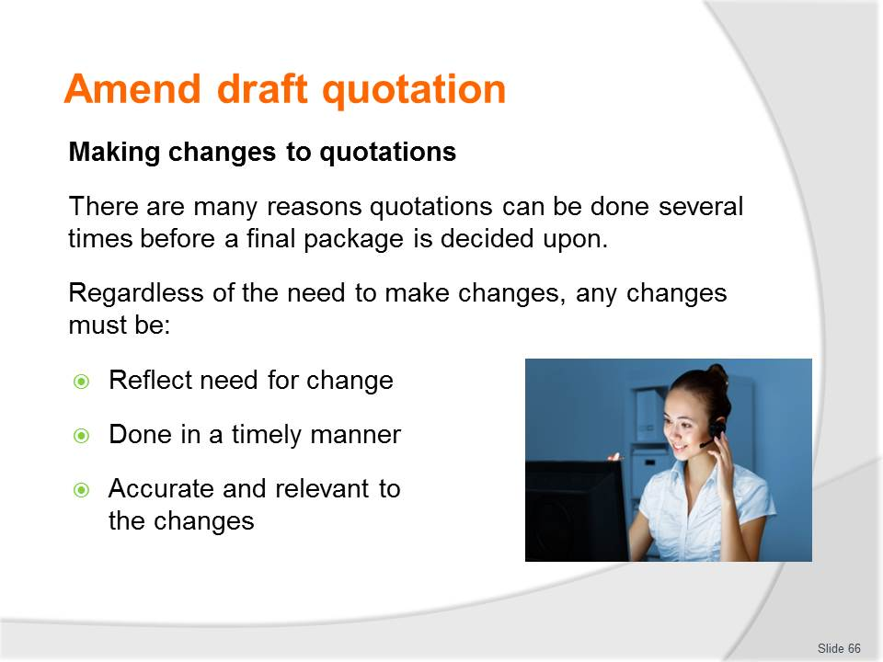
Slide No | Trainer Notes
Class Activity – Discuss reasons for change
- What are common reasons for changes to quotations?
- What causes these?
- How will they impact on quotations?

Slide
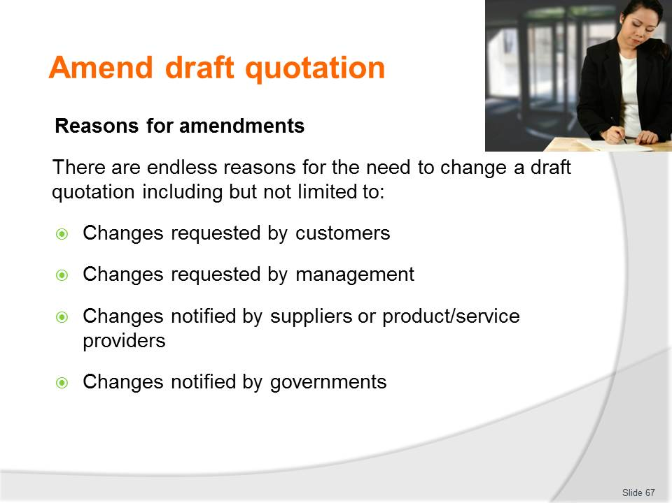
Slide No | Trainer Notes
Class Activity – Discuss reasons for amendments
- What are common reasons by each of these stakeholders
- How will they impact on quotations?

Slide
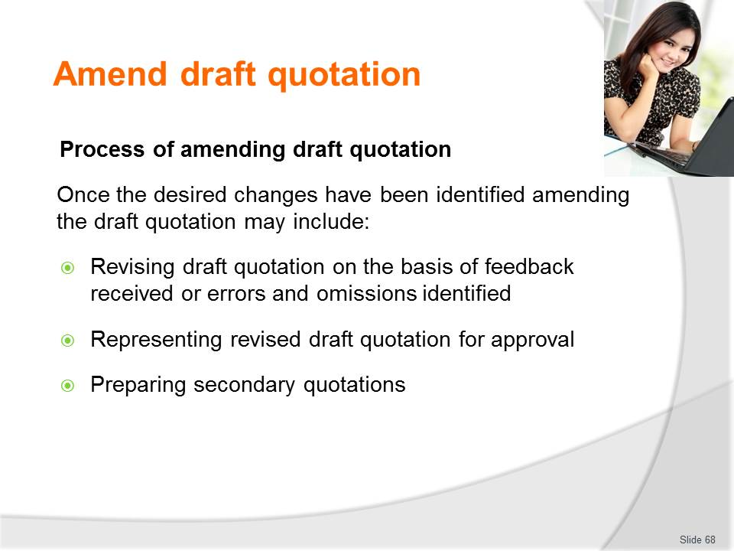
Slide No | Trainer Notes
Class Activity – Discuss points
- Discuss points
- Trainer to highlight any points for consideration.

Slide
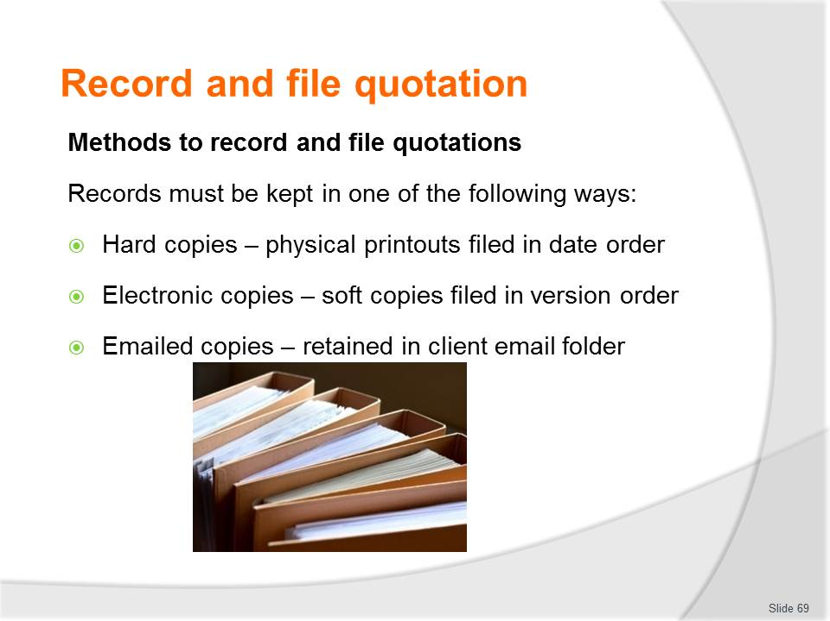
Slide No | Trainer Notes
Class Activity – Demonstrate filing methods
- Trainer show how files are to be maintained.

Slide
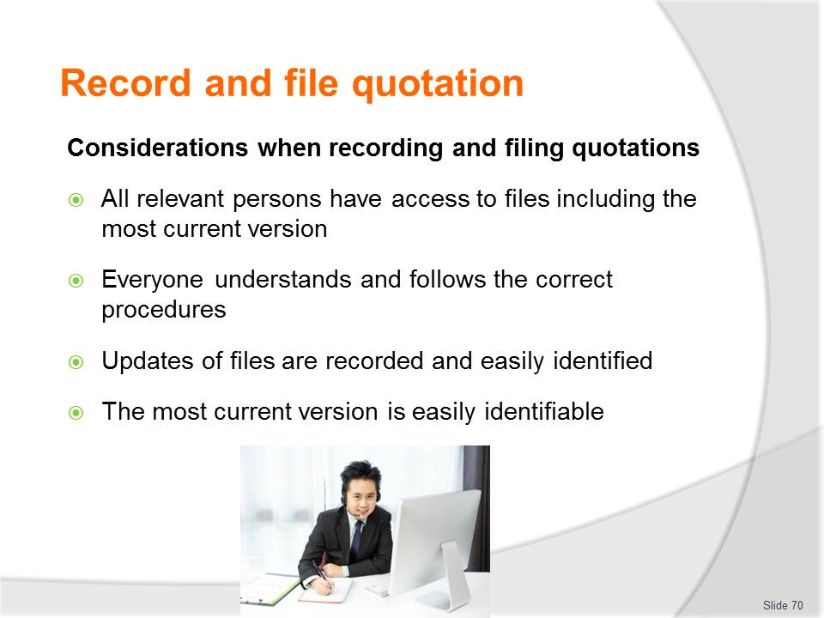
Slide No | Trainer Notes
Class Activity – Discuss points
- Discuss points
- Trainer to highlight any points for consideration.

Slide

Slide No | Trainer Notes
Introduce topic
Class Activity – General Discussion
Ask general questions:
- What are considerations when sending and presenting a quotation to a customer?
- What needs to be prepared before a presentation?

Slide
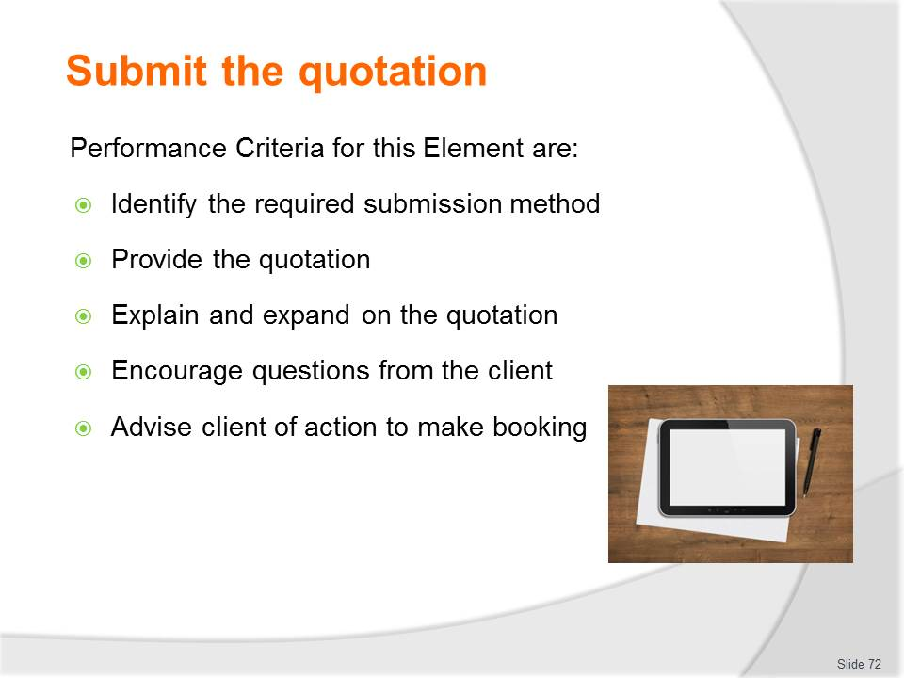
Slide No | Trainer Notes
 | Trainer identifies the Performance Criteria for this Element, as listed on the slide.

Slide
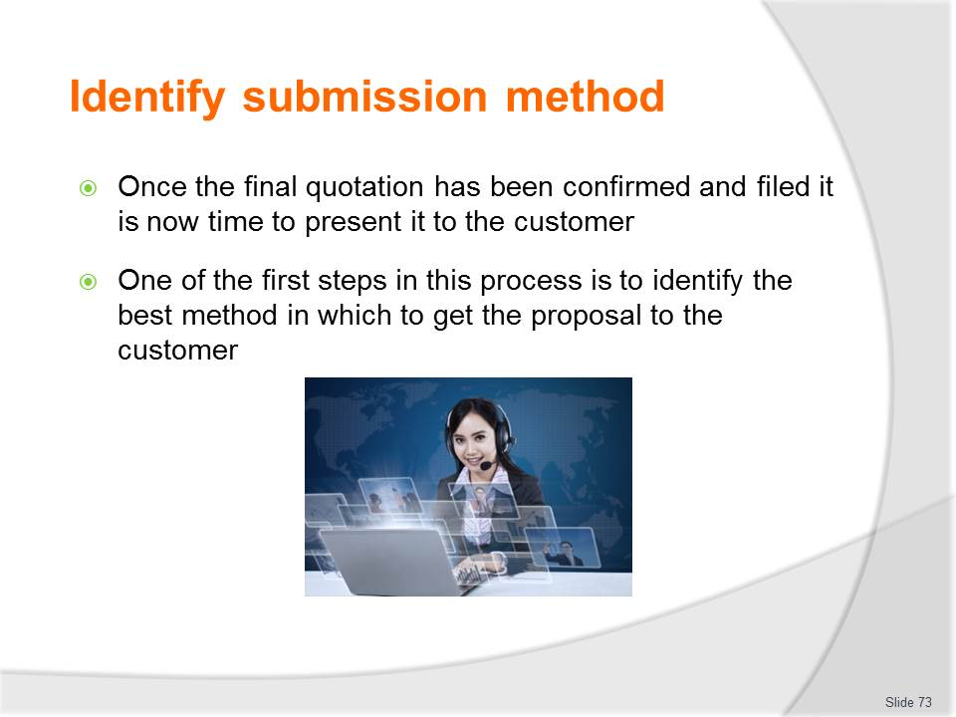
Slide No | Trainer Notes
Class Activity – Questions
- What methods exist?
- What needs to be considered before selecting a submission method?

Slide
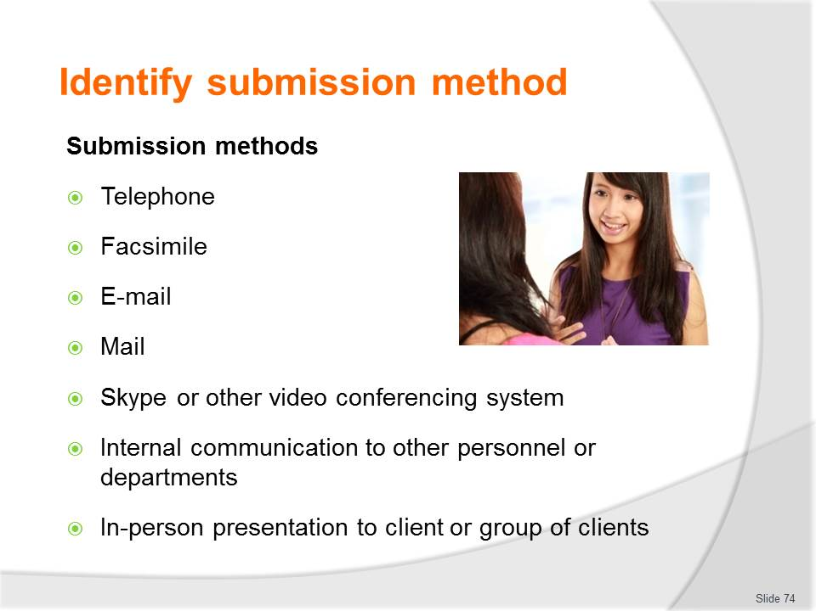
Slide No | Trainer Notes
Class Activity – Discuss submission methods
- What are the advantages / disadvantages for each of these submission methods.

Slide
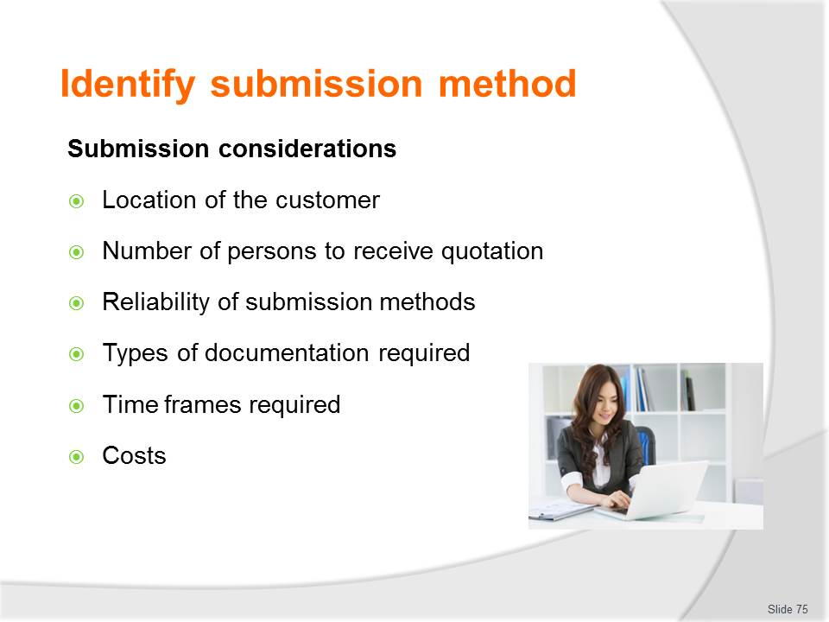
Slide No | Trainer Notes
Class Activity – Discuss submission considerations
- How do they impact submission methods?

Slide
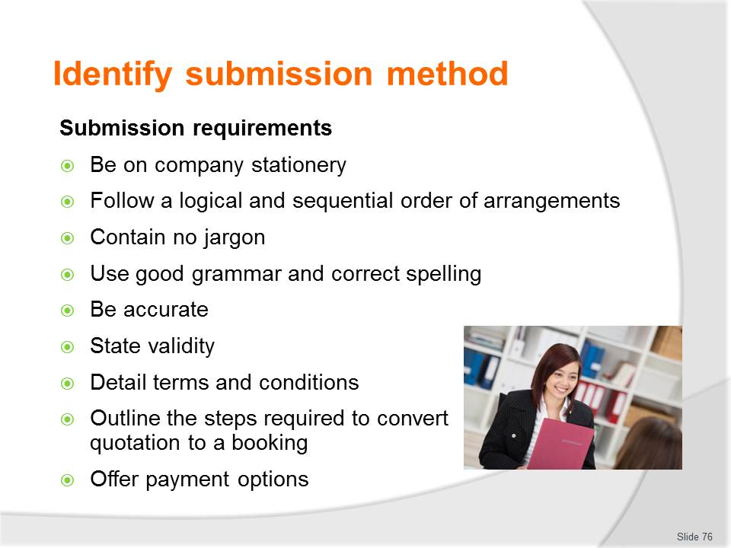
Slide No | Trainer Notes
Class Activity – Discuss submission techniques
- Trainer to show or explain various policies and procedures that impact on the preparation and delivery of final quotations.

Slide
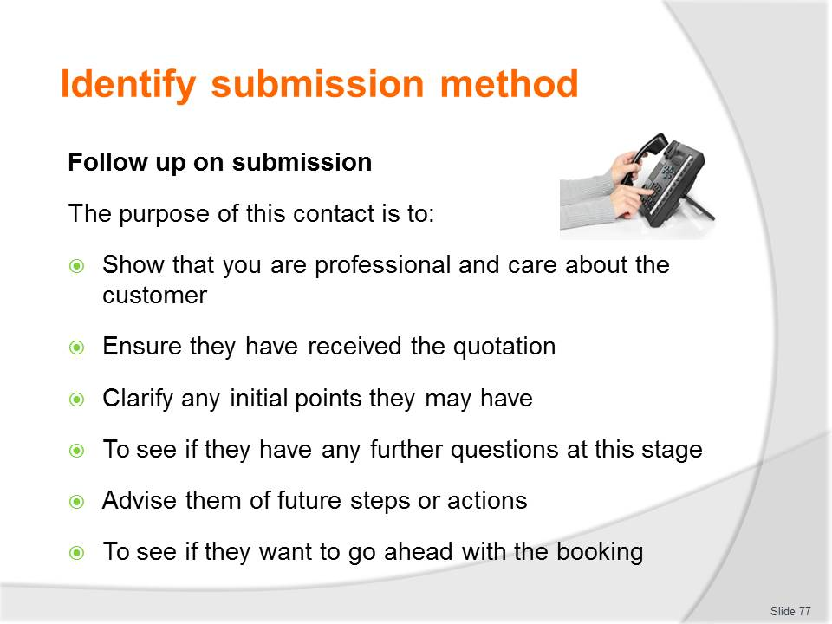
Slide No | Trainer Notes
Class Activity – Discussion
- Why is follow up so important?

Slide

Slide No | Trainer Notes
Class Activity – Discuss submission methods
- What are common timelines?
- How can you get it to someone ‘on the spot’?

Slide
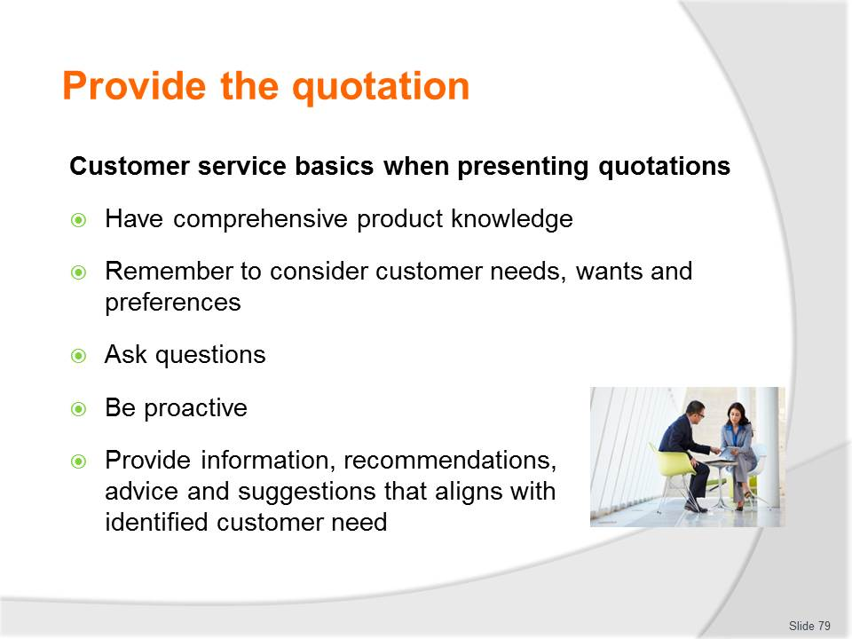
Slide No | Trainer Notes
Class Activity – Discuss importance of customer service basics
- Trainer to discuss importance of these customer service basics points.

Slide
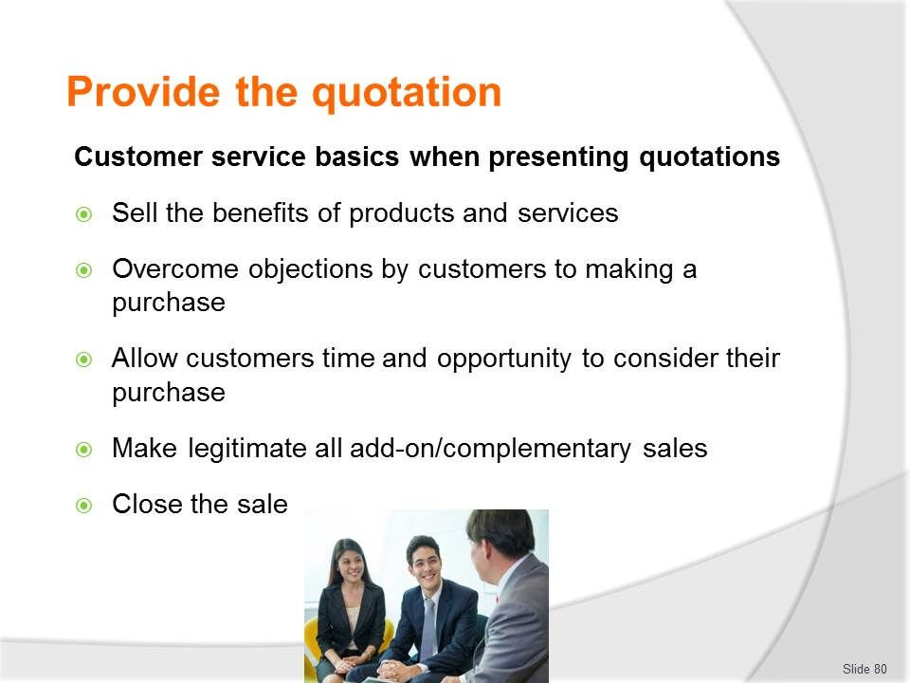
Slide No | Trainer Notes
Class Activity – Discuss importance of customer service basics
- Trainer to discuss importance of these customer service basics points.

Slide
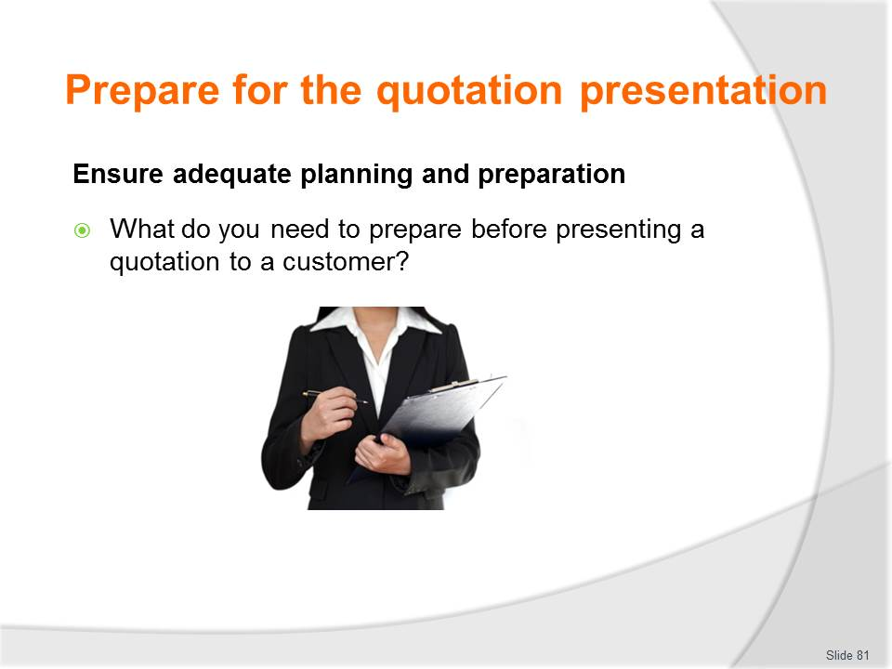
Slide No | Trainer Notes
Class Activity – Discuss preparation questions in the slide
- Trainer to list activities or show relevant SOP or task sheet.

Slide
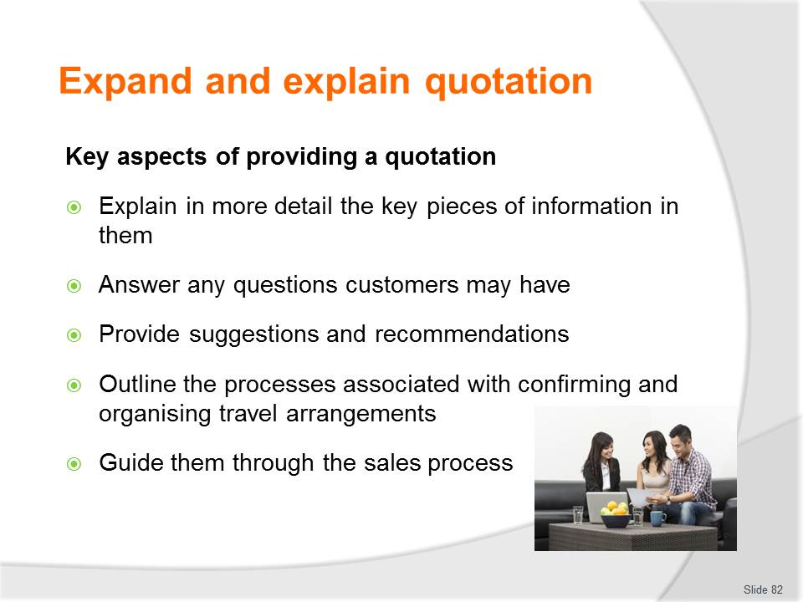
Slide No | Trainer Notes
Class Activity Role Play – Providing a quotation to a customer (Slides 82 – 93)
Again, in groups and either based on Work Activities case study or Trainer’s scenarios, provide quotation to a customer.
Trainer to demonstrate steps, key activities and important points.

Slide
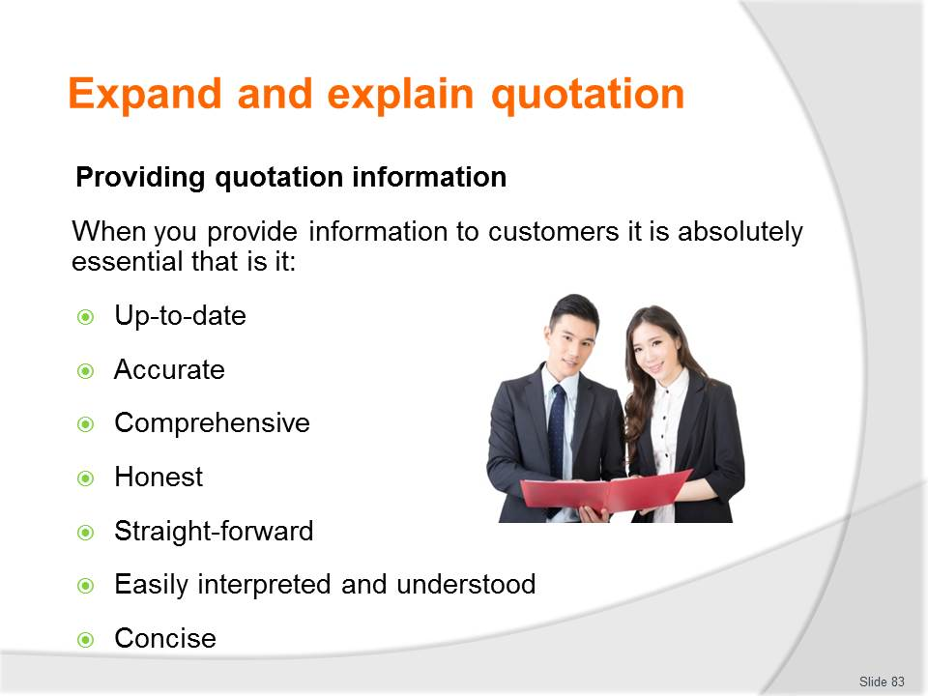
Slide No | Trainer Notes
Class Activity Role Play – Providing a quotation to a customer (Slides 82 – 93)
Again, in groups and either based on Work Activities case study or Trainer’s scenarios, provide quotation to a customer.
Trainer to demonstrate steps, key activities and important points.

Slide
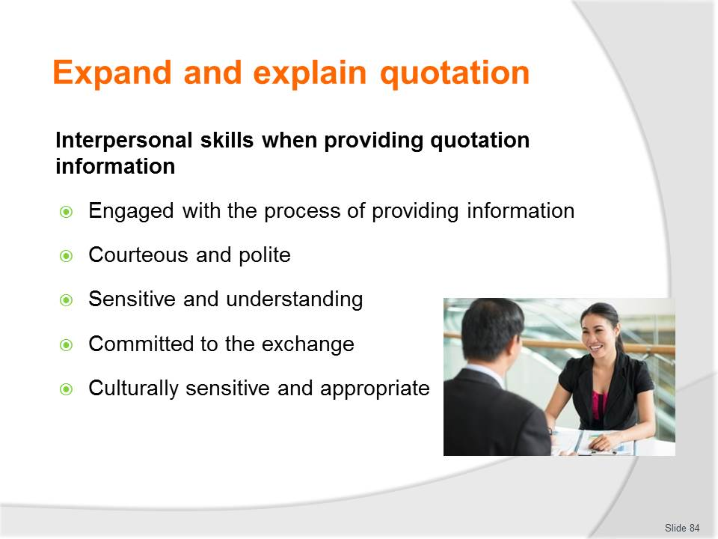
Slide No | Trainer Notes
Class Activity Role Play – Providing a quotation to a customer (Slides 82 – 93)
Again, in groups and either based on Work Activities case study or Trainer’s scenarios, provide quotation to a customer.
Trainer to demonstrate steps, key activities and important points.

Slide
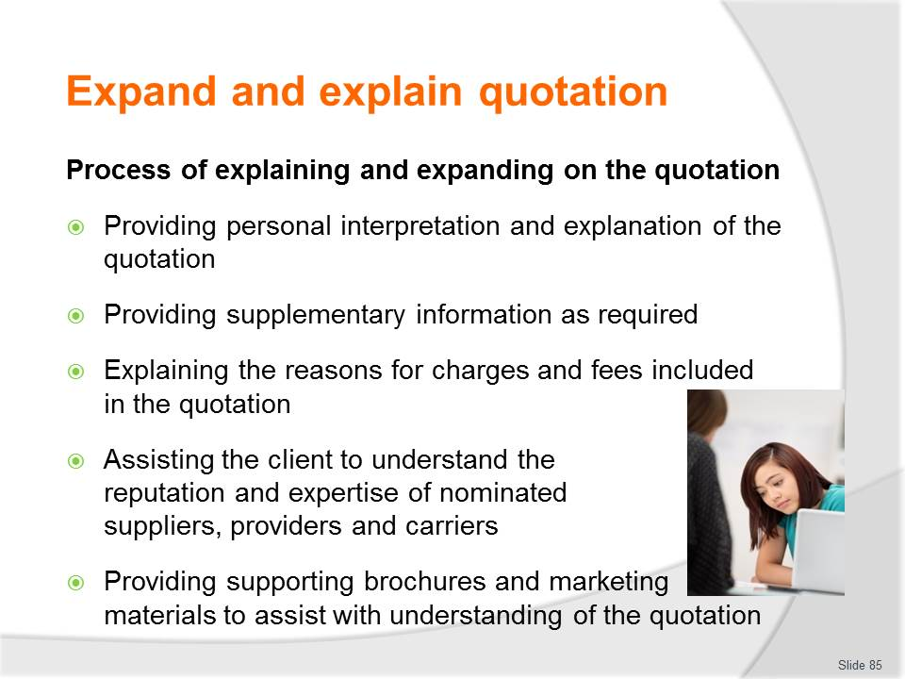
Slide No | Trainer Notes
Class Activity Role Play – Providing a quotation to a customer (Slides 82 – 93)
Again, in groups and either based on Work Activities case study or Trainer’s scenarios, provide quotation to a customer.
Trainer to demonstrate steps, key activities and important points.

Slide
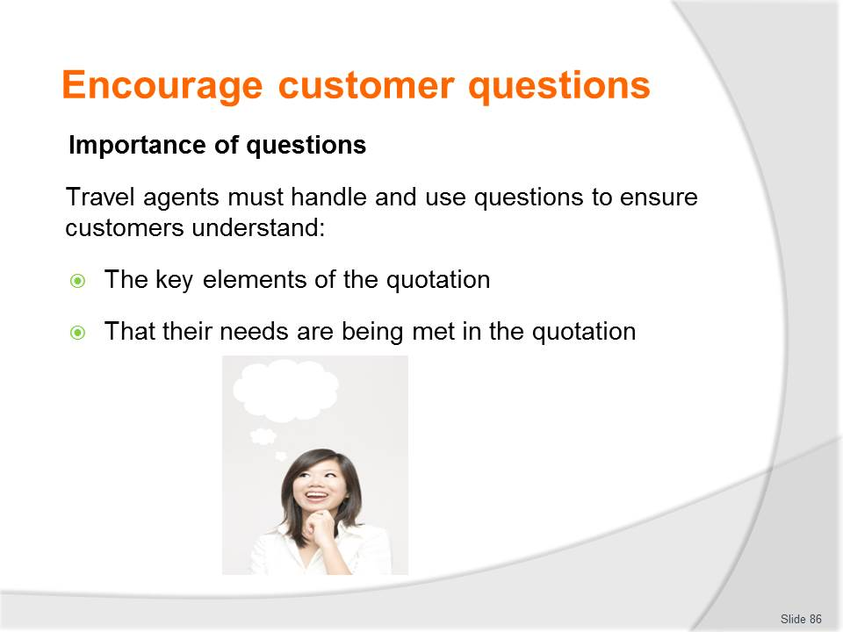
Slide No | Trainer Notes
Class Activity Role Play – Providing a quotation to a customer (Slides 82 – 93)
Again, in groups and either based on Work Activities case study or Trainer’s scenarios, provide quotation to a customer.
Trainer to demonstrate steps, key activities and important points:
- What are questions that should be asked?

Slide
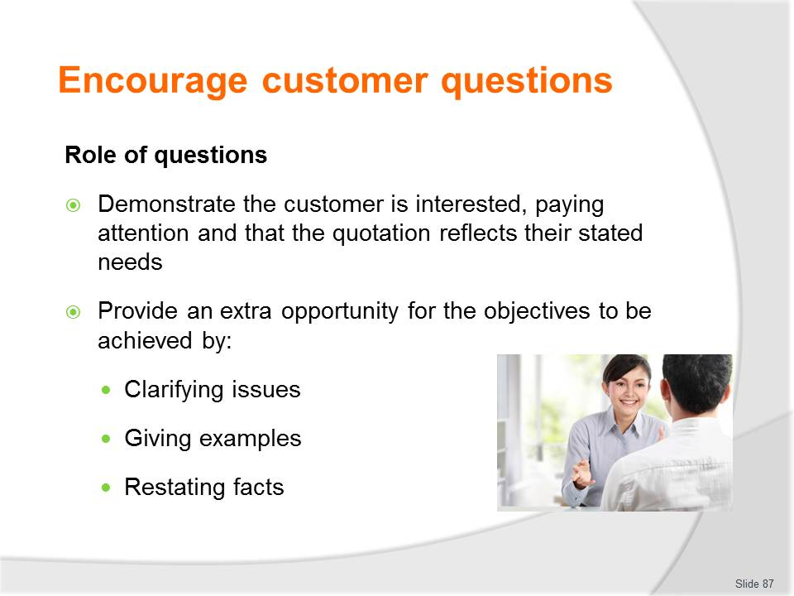
Slide No | Trainer Notes
Class Activity Role Play – Providing a quotation to a customer (Slides 82 – 93)
Again, in groups and either based on Work Activities case study or Trainer’s scenarios, provide quotation to a customer.
Trainer to demonstrate steps, key activities and important points.

Slide
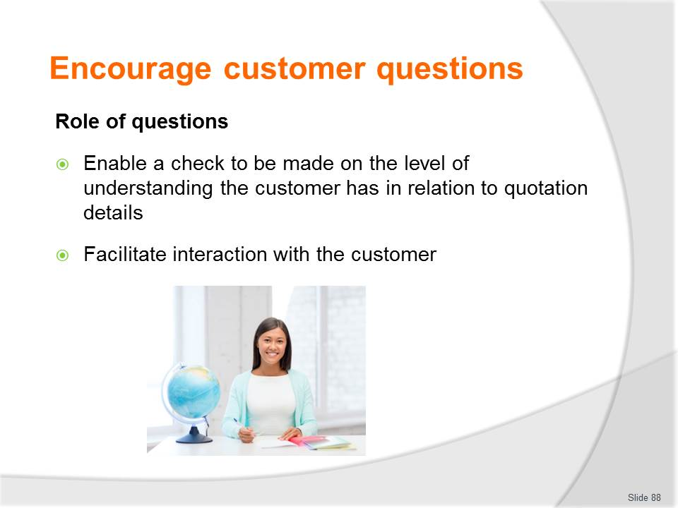
Slide No | Trainer Notes
Class Activity Role Play – Providing a quotation to a customer (Slides 82 – 93)
Again, in groups and either based on Work Activities case study or Trainer’s scenarios, provide quotation to a customer.
Trainer to demonstrate steps, key activities and important points.

Slide
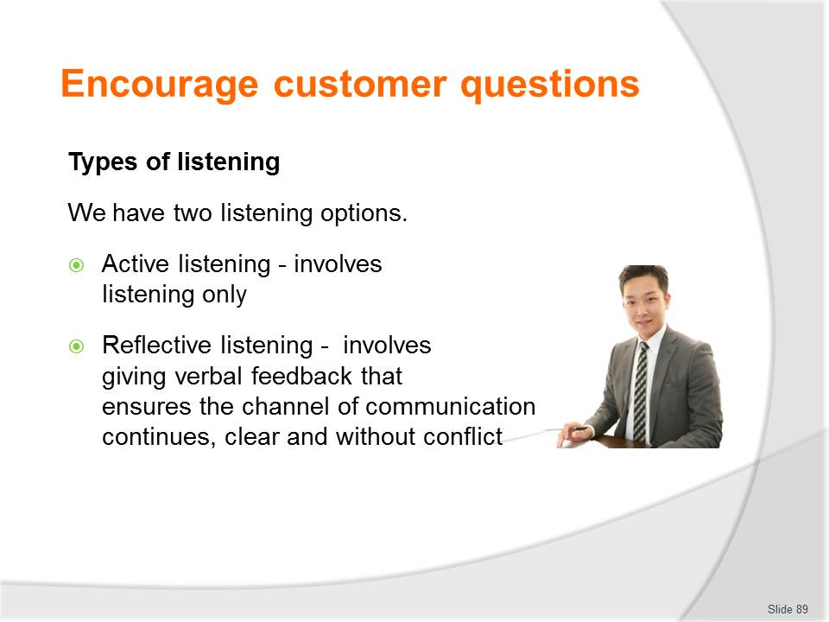
Slide No | Trainer Notes
Class Activity Role Play – Providing a quotation to a customer (Slides 82 – 93)
Again, in groups and either based on Work Activities case study or Trainer’s scenarios, provide quotation to a customer.
Trainer to demonstrate steps, key activities and important points.

Slide
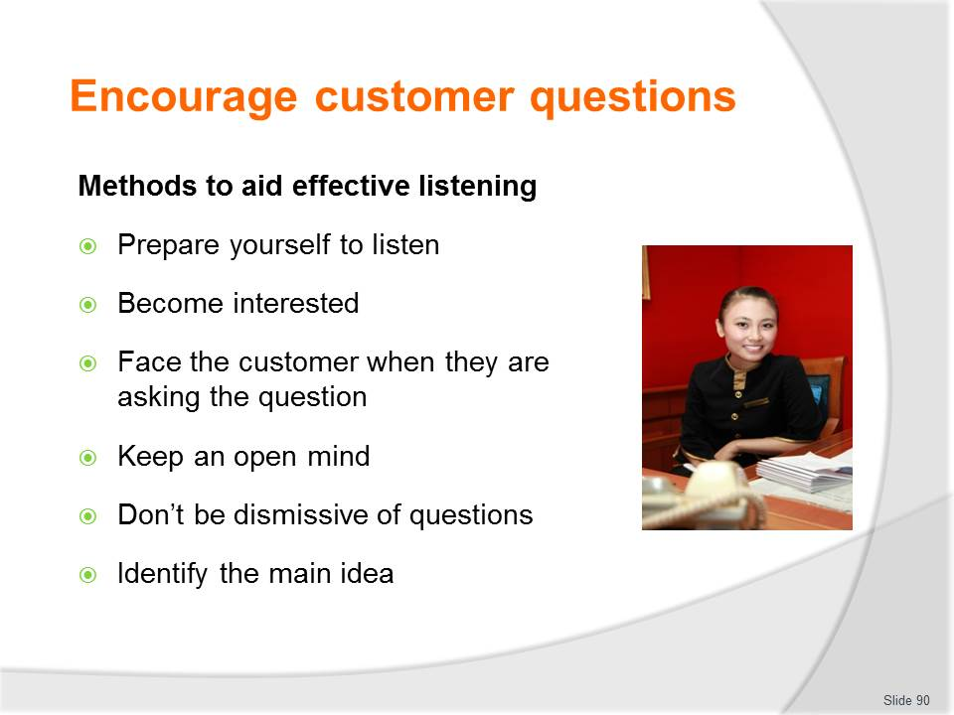
Slide No | Trainer Notes
Class Activity Role Play – Providing a quotation to a customer (Slides 82 – 93)
Again, in groups and either based on Work Activities case study or Trainer’s scenarios, provide quotation to a customer.
Trainer to demonstrate steps, key activities and important points.

Slide
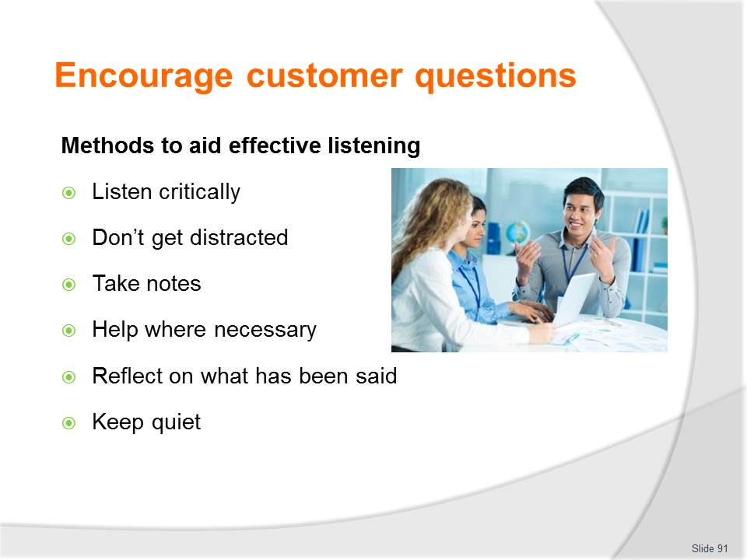
Slide No | Trainer Notes
Class Activity Role Play – Providing a quotation to a customer (Slides 82 – 93)
Again, in groups and either based on Work Activities case study or Trainer’s scenarios, provide quotation to a customer.
Trainer to demonstrate steps, key activities and important points.

Slide
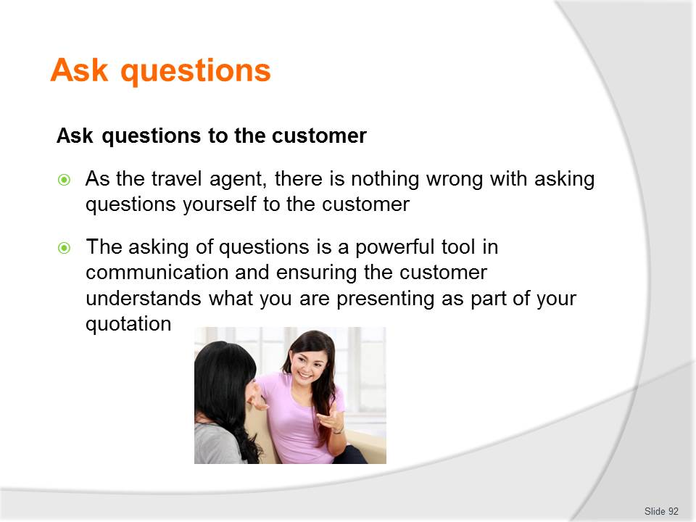
Slide No | Trainer Notes
Class Activity Role Play – Providing a quotation to a customer (Slides 82 – 93)
Again, in groups and either based on Work Activities case study or Trainer’s scenarios, provide quotation to a customer.
Trainer to demonstrate steps, key activities and important points.

Slide

Slide No | Trainer Notes
Class Activity Role Play – Providing a quotation to a customer (Slides 82 – 93)
Again, in groups and either based on Work Activities case study or Trainer’s scenarios, provide quotation to a customer.
Trainer to demonstrate steps, key activities and important points.

Slide
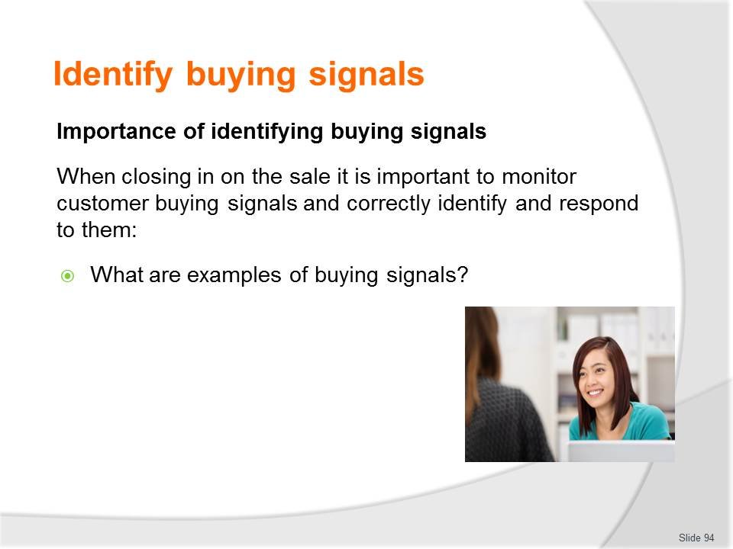
Slide No | Trainer Notes
Class Activity – Questions
- Discuss question in the slide.

Slide
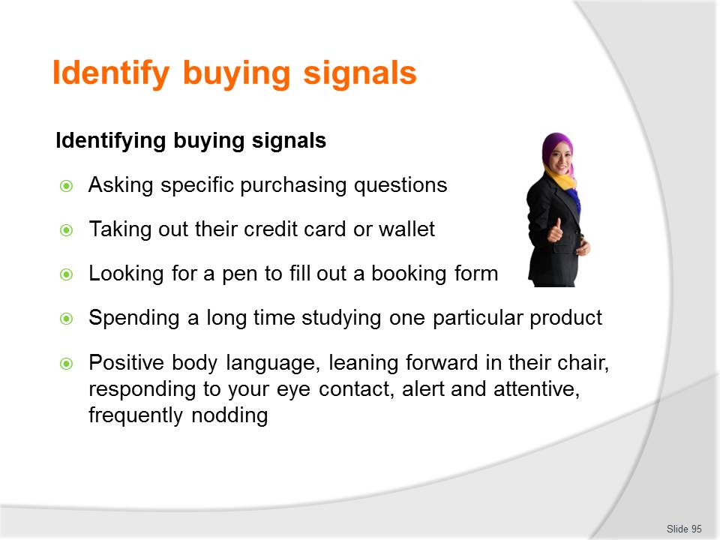
Slide No | Trainer Notes
Class Discussion – Questions
- What other buying signs are there?
- What should you do when you see a buying sign?

Slide
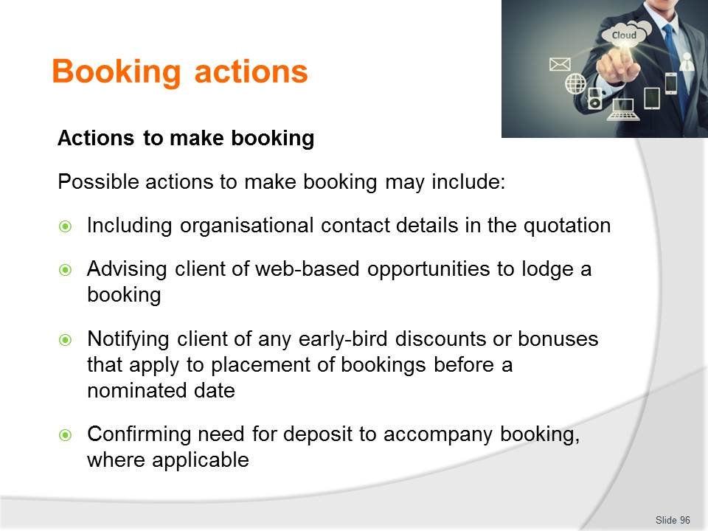
Slide No | Trainer Notes
Class Activity Role Play – Suggest actions to make a booking
Trainer to demonstrate steps, key activities and important points.

Slide

Slide No | Trainer Notes
Introduce topic
Class Activity – General Discussion
Ask general questions:
- What follow up activities need to take place?

Slide
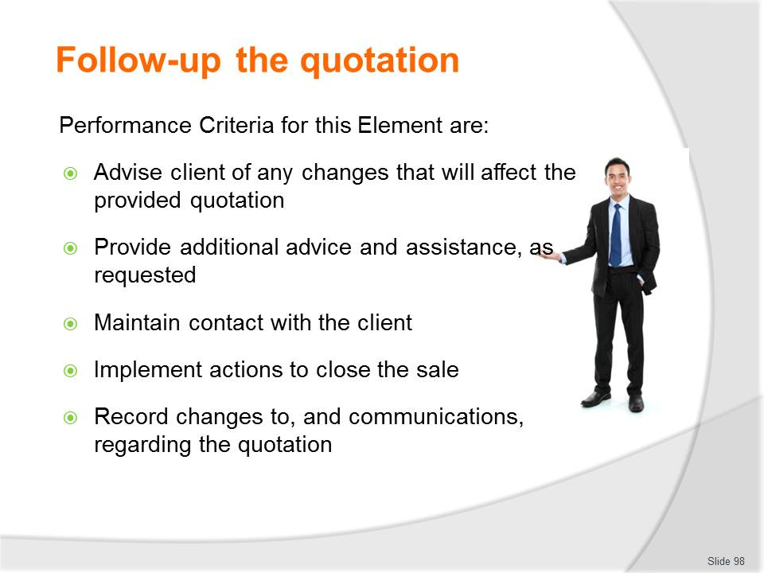
Slide No | Trainer Notes
 | Trainer identifies the Performance Criteria for this Element, as listed on the slide.

Slide
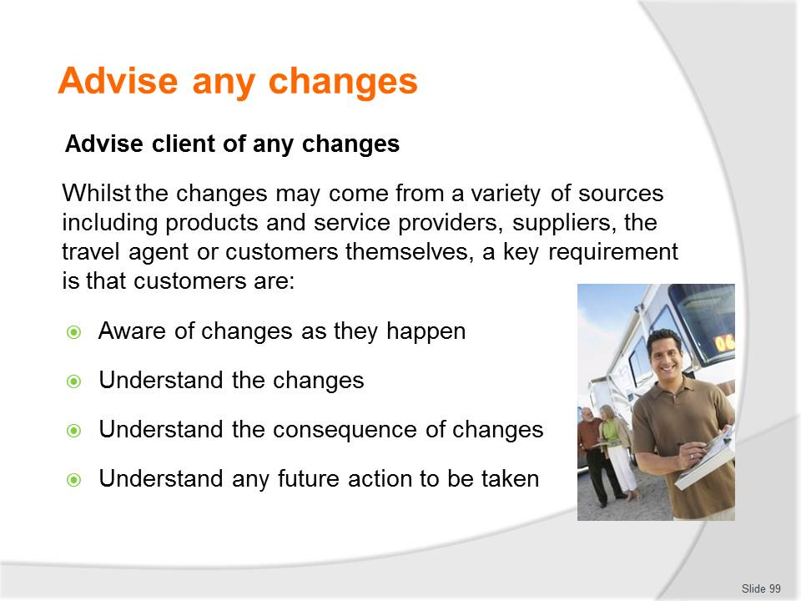
Slide No | Trainer Notes
Class Discussion – Questions
- Why is it important that customers are kept up to date with changes?
- How can you keep them updated?

Slide
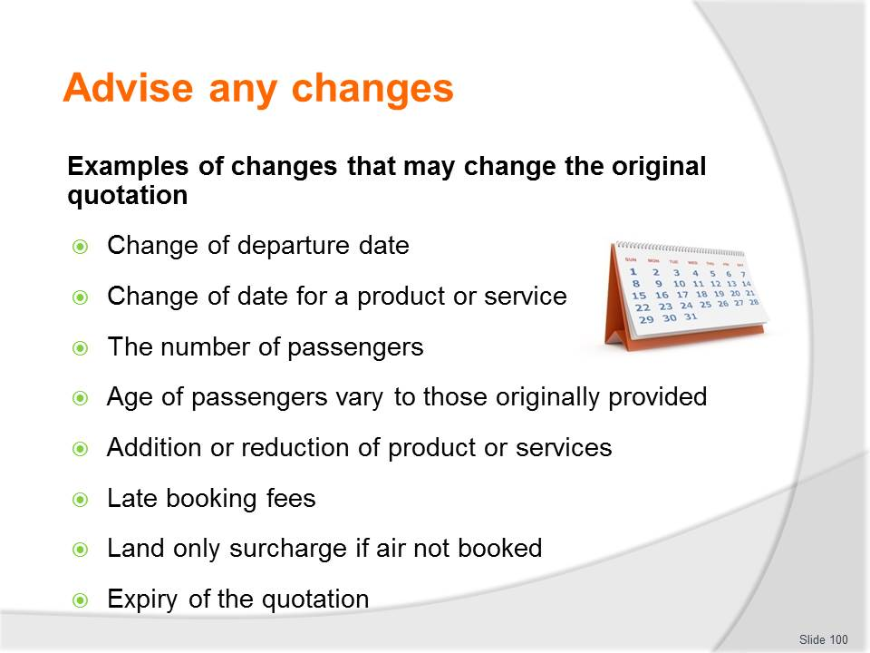
Slide No | Trainer Notes
Class Discussion – Discuss changes
- What is the cause?
- How do they impact on a quotation and it’s costs.

Slide

Slide No | Trainer Notes
Class Discussion – Questions
- Discuss question in the slide
- Trainer to provide examples based on personal experience.

Slide
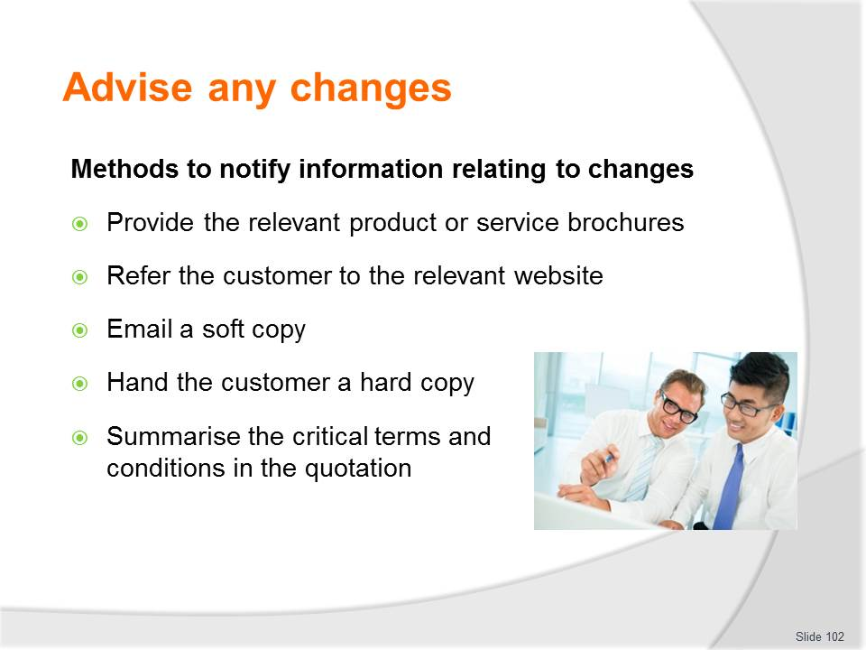
Slide No | Trainer Notes
Class Discussion – Questions
- Which methods are preferred and why?

Slide
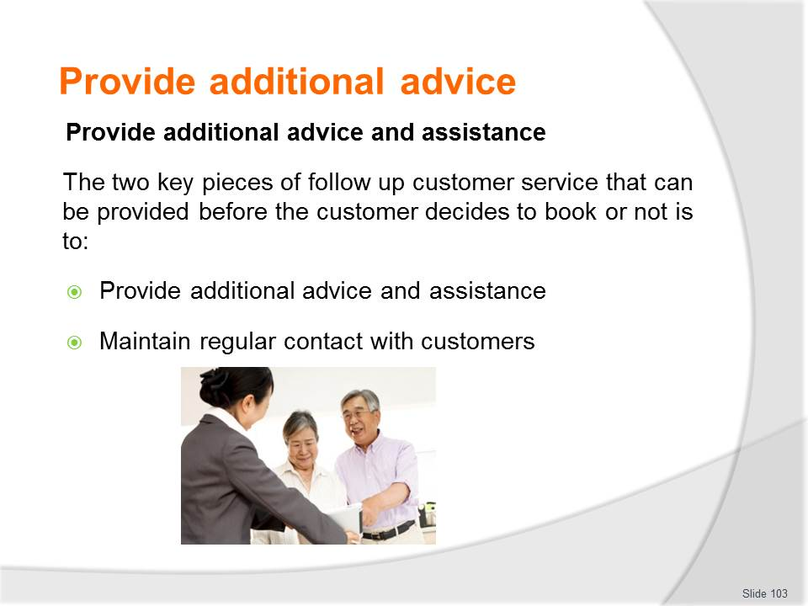
Slide No | Trainer Notes
Class Discussion – Questions
- What is the role of each these activities?
- What are the tasks associated with each?

Slide

Slide No | Trainer Notes
Class Discussion – Questions
- Discuss questions in the slide.

Slide
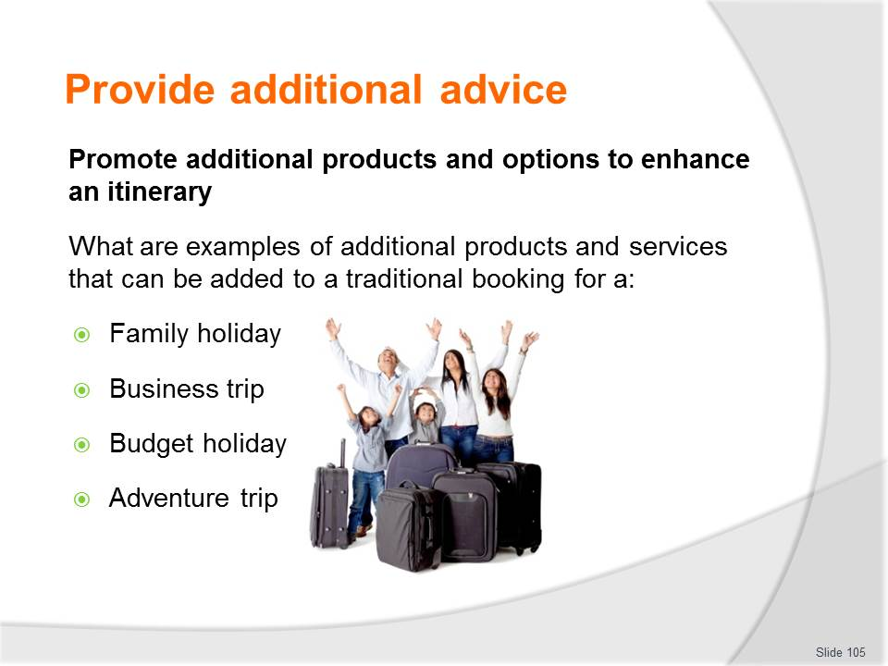
Slide No | Trainer Notes
Class Discussion – Activity
- Trainer to lead the activity described in this slide.

Slide
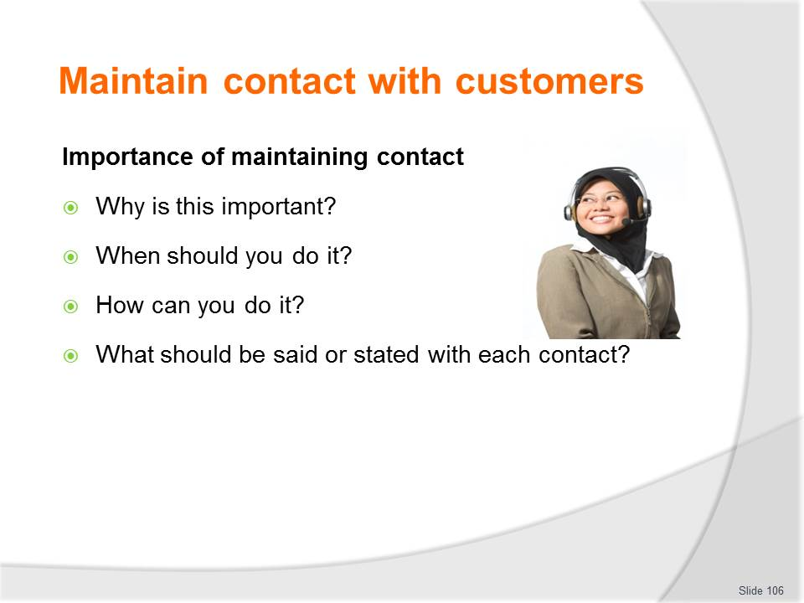
Slide No | Trainer Notes
Class Discussion – Questions
- Discuss the questions in this slide.

Slide
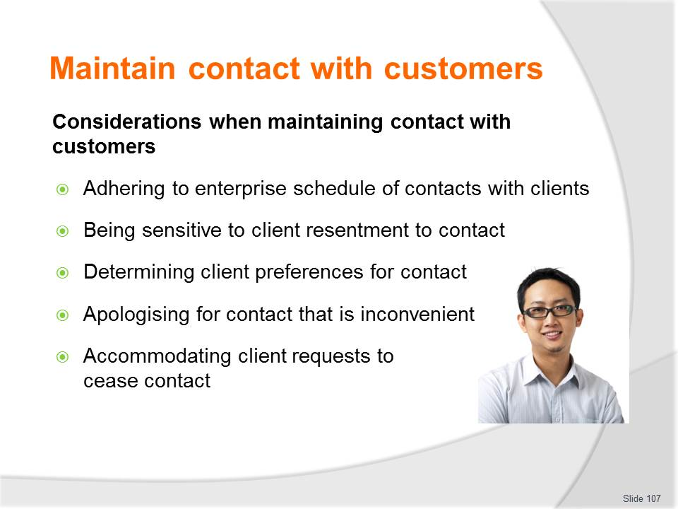
Slide No | Trainer Notes
Class Discussion
- Discuss the importance of these considerations.

Slide

Slide No | Trainer Notes
Class Discussion – Questions and Demonstration
- Why is it important to record client contact conversations?
- How can they be recorded?
- Trainer to demonstrate how to keep updated recordings of client contact conversations.

Slide

Slide No | Trainer Notes
Class Discussion – Role play
- Trainer to demonstrate how to encourage a purchase
- Audience to practice in pairs.

Slide
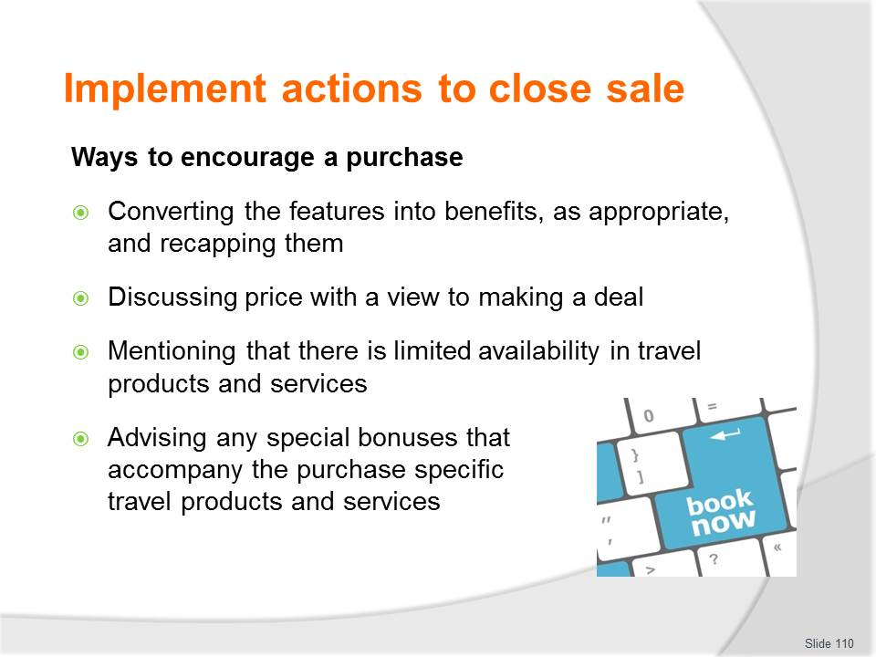
Slide No | Trainer Notes
Class Discussion – Role play
- Trainer to demonstrate how to encourage a purchase
- Audience to practice in pairs.

Slide

Slide No | Trainer Notes
Class Discussion – Role play
- Trainer to demonstrate how to encourage a purchase
- Audience to practice in pairs.

Slide
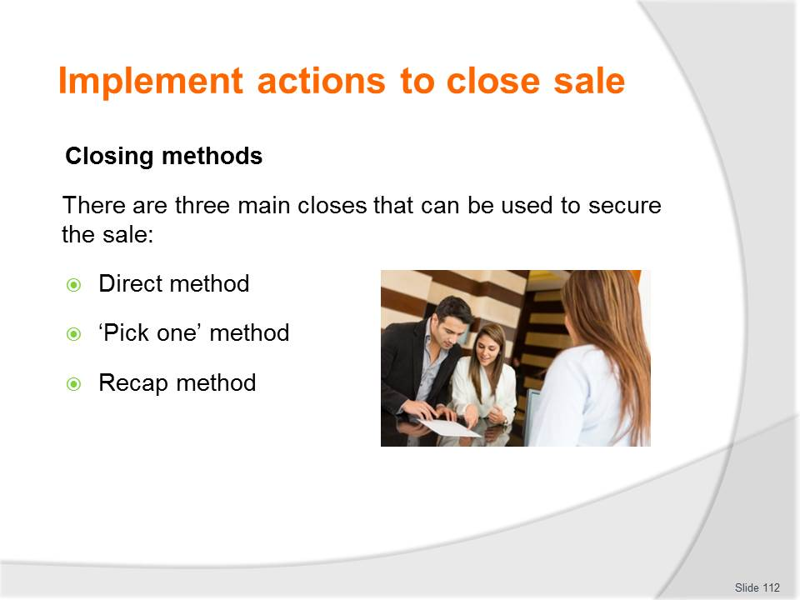
Slide No | Trainer Notes
Class Discussion – Questions and Role play
- What is the difference in these closing methods?
- When would each of these methods be the most appropriate?
- Trainer to demonstrate how of closing methods
- Audience to practice in pairs.

Slide
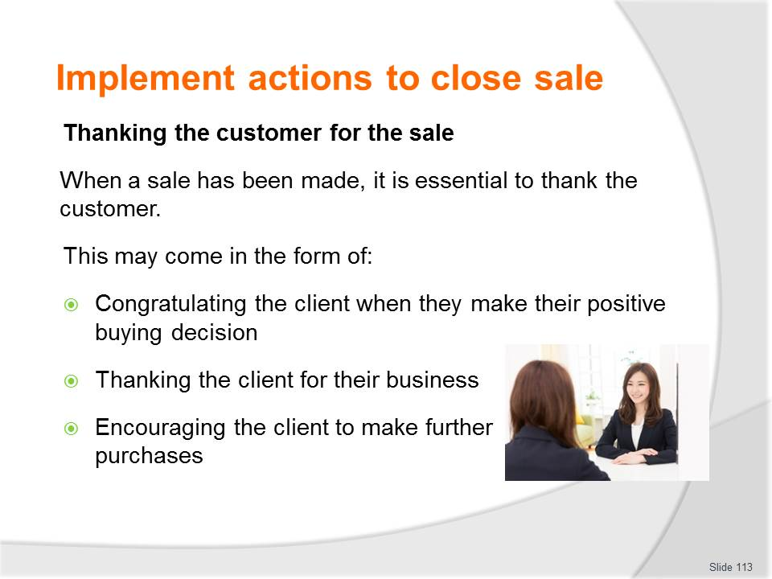
Slide No | Trainer Notes
Class Discussion – Role play
- Trainer to demonstrate how to thank the customer
- Audience to practice in pairs.

Slide
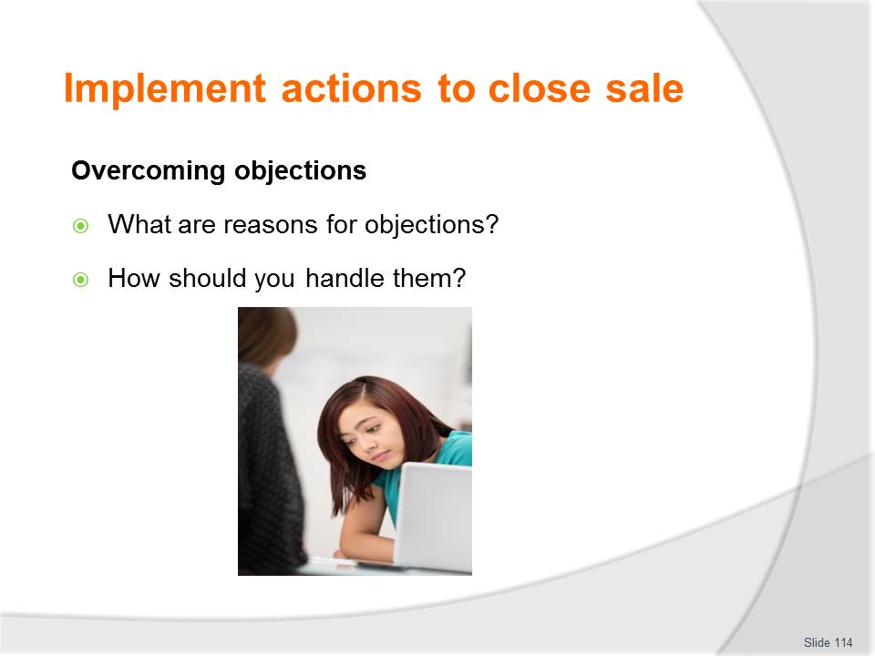
Slide No | Trainer Notes
Class Discussion – Questions and Role play
- Discuss the questions in the slide
- Trainer to demonstrate how to overcome objections
- Audience to practice in pairs.

Slide
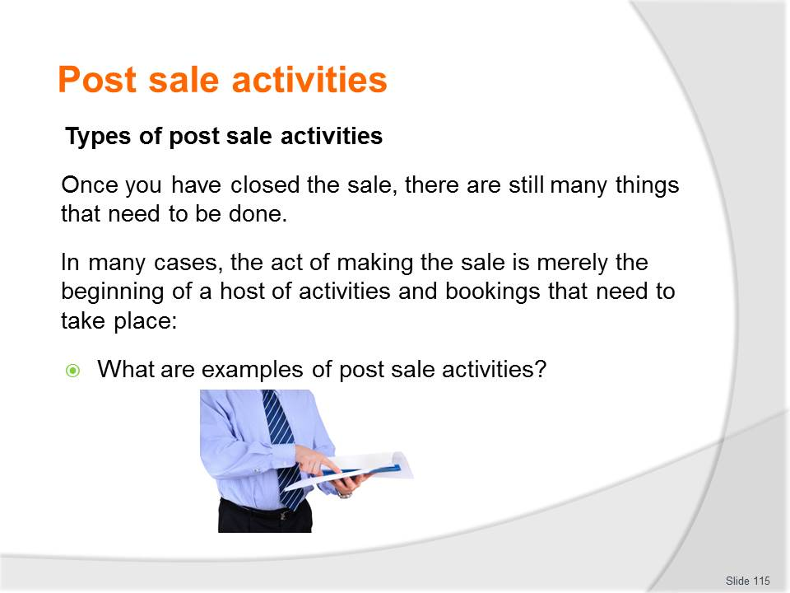
Slide No | Trainer Notes
Class Discussion – Questions and List post sale activities
- Discuss the question in the slide
- Develop a list of post-sale activities.

Slide
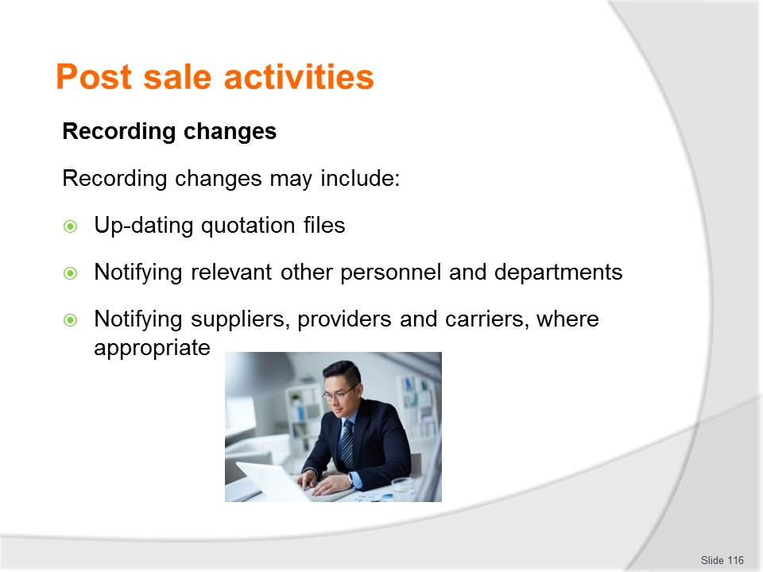
Slide No | Trainer Notes
Class Discussion – Questions and Demonstration
- How and when should you record changes
- Trainer to demonstrate methods including being able to identify ‘most current version’.

Slide
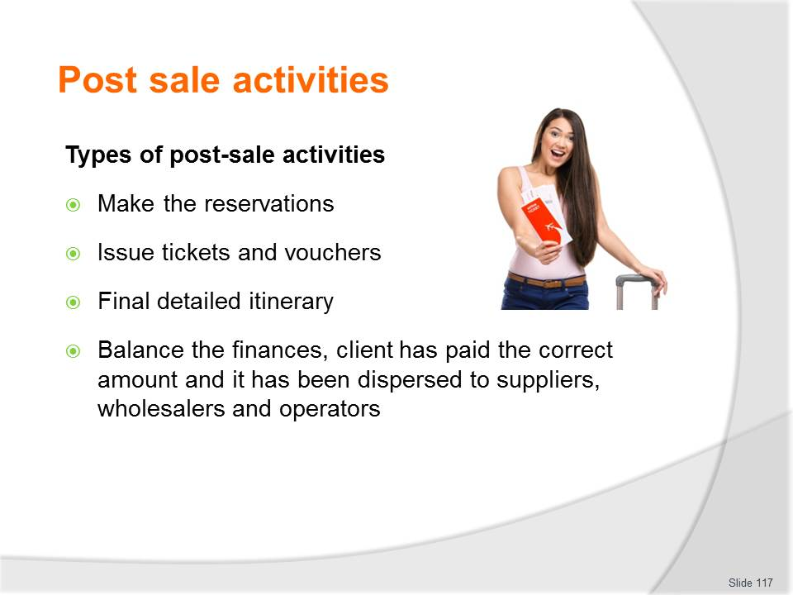
Slide No | Trainer Notes
Class Discussion – Demonstrate, Discussion and Role Play
- Trainer to demonstrate (where possible) and discuss the different post-sale activities
- Where possible, audience should role play post-sale activities.

Slide
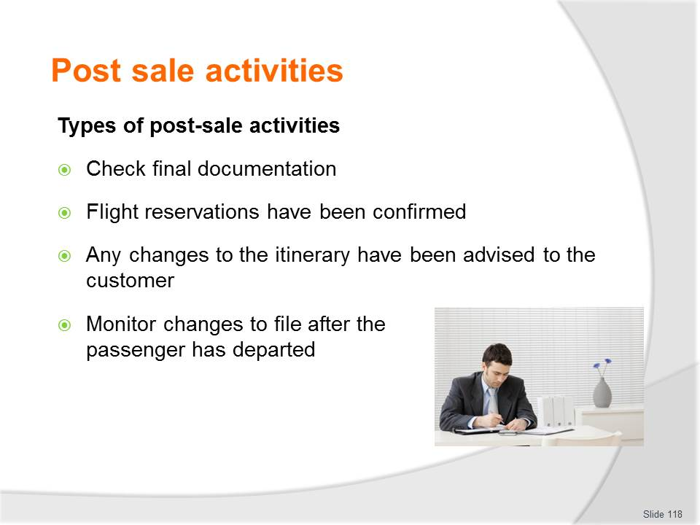
Slide No | Trainer Notes
Class Discussion – Demonstrate, Discussion and Role Play
- Trainer to demonstrate (where possible) and discuss the different post-sale activities
- Where possible, audience should role play post-sale activities.

Slide
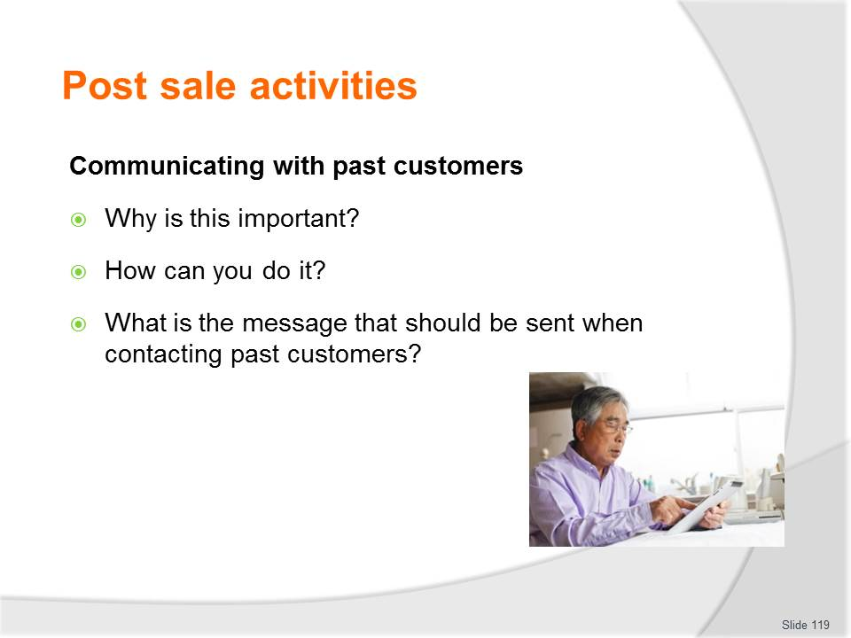
Slide No | Trainer Notes
Class Discussion – Questions
- Discuss the questions in the slide.

Slide

Slide No | Trainer Notes
This is the conclusion of the subject.
Thank the audience and deliver assessments as required.

Recommended training equipment
- Computer access
- Customer information recording forms
- Final contracts / quotations
- Formal quotation templates
- Industry codes:
- Airport codes
- Airline codes
- Tour codes
- Room types
- Service codes
- Internet access
- Quotation examples
- Quotation Planner
- Quotation SOP's
- Terms and conditions including:
- Travel Agent Terms and Conditions
- Supplier Terms and Conditions
- Product or service provider terms and conditions
- Travel and tourism related products and services information including:
- Brochures/DVDs
- Hotel and accommodation guides and indexes
- Atlases, maps and encyclopedias
- Travel guides
- Individual timetables
- Automated information systems
- Computerised Reservations Systems (CRS)
- International airline guides
- Travel Trade Yearbook
- Travel Information Manual (TIM)
- Passenger air tariff
- Trade press
- General print and electronic media, travel magazines and even news bulletins for current issues

- Intranet Websites
- Internal information databases
- Product manuals
- Supplier information and sales kits
- Industry tariffs

Instructions for Trainers for using
PowerPoint – Presenter View
Connect your laptop or computer to your projector equipment as per manufacturers’ instructions.
In PowerPoint, on the Slide Show menu, click Set up Show.
Under Multiple monitors, select the Show Presenter View check box.
In the Display slide show on list, click the monitor you want the slide show presentation to appear on.
Source: http://office.microsoft.com
Note:
In Presenter View:
You see your notes and have full control of the presentation
Your trainees only see the slide projected on to the screen
More Information
You can obtain more information on how to use PowerPoint from the Microsoft Online Help Centre, available at: http://office.microsoft.com/training/training.aspx?AssetID=RC011298761033
Note Regarding Currency of URLs
Please note that where references have been made to URLs in these training resources trainers will need to verify that the resource or document referred to is still current on the internet. Trainers should endeavour, where possible, to source similar alternative examples of material where it is found that either the website or the document in question is no longer available online.

Appendix – ASEAN acronyms
AADCP | ASEAN – Australia Development Cooperation Program
ACCSTP | ASEAN Common Competency Standards for Tourism Professionals
AEC | ASEAN Economic Community
AMS | ASEAN Member States
ASEAN | Association of Southeast Asian Nations
ASEC | ASEAN Secretariat
ATM | ASEAN Tourism Ministers
ATPMC | ASEAN Tourism Professionals Monitoring Committee
ATPRS | ASEAN Tourism Professional Registration System
ATFTMD | ASEAN Task Force on Tourism Manpower Development
CATC | Common ASEAN Tourism Curriculum
MRA | Mutual Recognition Arrangement
MTCO | Mekong Tourism Coordinating office
NTO | National Tourism Organisation
NTPB | National Tourism Professional Board
RQFSRS | Regional Qualifications Framework and Skills Recognition System
TPCB | Tourism Professional Certification Board





